Department of Biochemistry
Name of Program : Awareness Programme on Cancer
Resource Person : Dr. Shama Sultana,Chair Women, Chief Gyneocologist, Hope Win Hospitals,Guntur.
Number of Participants : 200 members
Date : 3/02 /2026
Brief Report : Department of Biochemistry and NSS units in association with JCI India foundation organised an Awareness programme on cancer to educate participants about early detection, prevention, and healthy lifestyle practices. As a part of the programme, a Memorandum of Understanding (MoU) was formally signed between the institution and a JCI India foundation a Non-Governmental Organization (NGO) to strengthen collaboration in health awareness and community outreach activities. The programme concluded with an awareness rally.
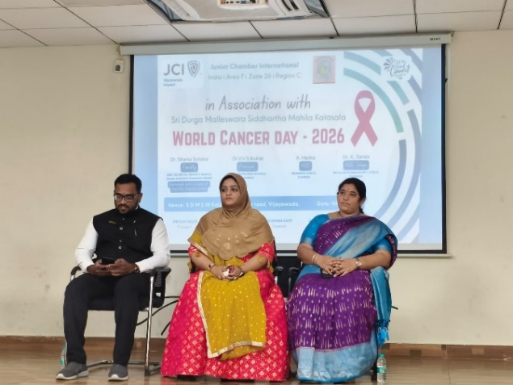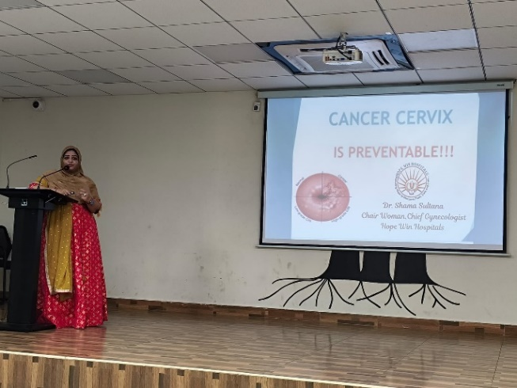

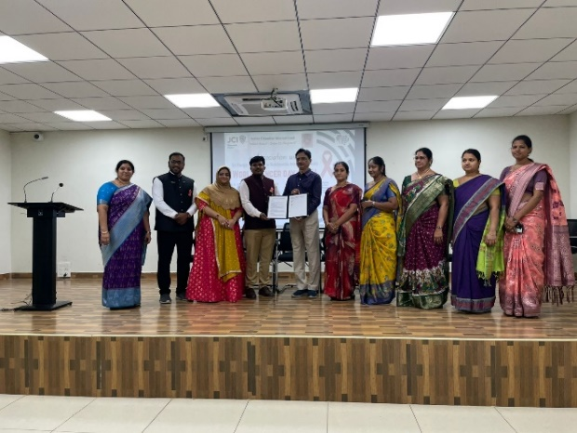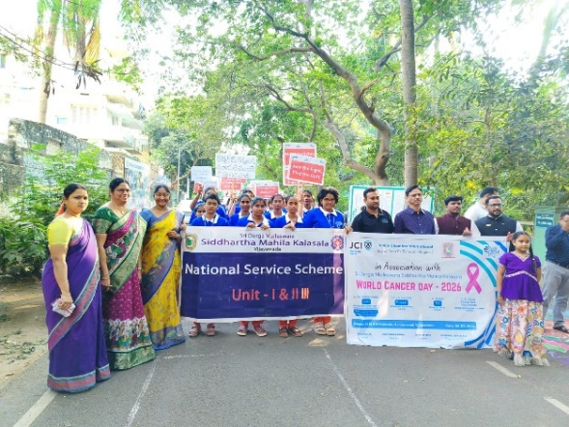

Department of Biochemistry
Name of Program : One Day International Seminar -BIOSPARK-2K26
Resource Person : Dr. M.N.V.Ravi Kiran
Director,Center For Converge Bioscience and Medicine University of Alabama,U.S.

Number of Participants : 200 members
Date : 23/02 /2026
Brief Report :
Department of Biochemistry organised an One Day International Seminar on Emerging Your Global Future Through Research and Innovation.The seminar featured an insightful session by the Resource Person who shared expertise on global research trends and innovation.It aimed to promote a research-oriented mindset among students and faculty.Participants actively engaged in discussions and gained valuable knowledge on emerging opportunities.
