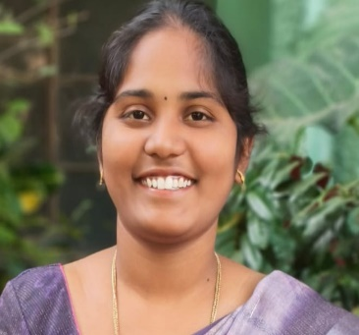
Name: Mandula Deepika
Email id: deepikamandula11@gmail.com
Phn no: 8367375783

EDUCATION QUALIFICATION:

- I have Completed my Masters of Business Administration (MBA) in Human Resource management (HR) with Affiliated to JNTU, Kakinada in 2023-2025 with Aggregate CGPA 7.2
- I have Completed my Bachelor of Technology (B.Tech) in Electronics and Communication Engineering (ECE) with Affiliated to JNTU, Kakinada in 2019-2023 with Aggregate CGPA 8.0
- I have completed my Intermediate MPC from Board of Intermediate Education with Aggregate CGPA 9.21
- I have Completed my SSC From Board of Secondary Education with Aggregate CGPA 9.0
SUBJECTS HANDLED:
- Introduction to Business Analytics
- Big Data Analytics
- Human Resource Analytics
- Business Analytics using text mining modelling using python
- Human resource management
- Universal Human Values
- Business organization
- Principles Of Management
- Analog and digital communications
- Internet of things

ACHIEVEMENTS:

- Secured a certificate with Institute of Electronics and Telecommunication Engineers (IETE) by IETE Student Form.
- Secured a certificate with South Central Railway in Signal and telecommunication department
- Secured a certificate with Brain O Vision on Java Full Stack Development.
- Secured a certificate with Oracle playbook for HR Excellence Training and Assessment.
- Completed a certification course With Maveen Silicon Through online program & Learned on VLSI SOC Design Using Verilog HDL.
- Completed a certification course With INFOSYS Through Online &Learned On
“Basics of python”.
- Completed a certification course with INFOSYS Through Online & Learned On “Java Programming Fundamentals”.
- Completed a certification course with INFOSYS Through Online & Learned On “Fundamentals of HR Management”.
- Completed a certification course with INFOSYS Through Online & Learned On “Introduction to Business Analytics”.
EXPERIENCE:

- Worked as Graduate Engineer Trainee – maintenance Electrical in the post of GET in Grade L08T at JSW. June 2023- November 2023.
- Worked as a Lecturer from November 2023 to September 2025 at Vijaya Institute of technology for Women, Vijayawada
- Working as a Lecturer from October 2025 to till date at Sri Durga Malleswara Siddhartha Mahila Kalasala.
ATTENDED FDP’S /WORKSHOPS:

- Attended a one-week FDP on AI/ML and Data Science for Industry 4.O (Intermediate level) From NITTR.
- Attended a one-week FDP on Wireless Embedded Systems From NITTR.
- Attended a five-day FDP on Inculcating Universal Human values in Technical Education organized by AICTE
- Attended FDP on R-Programming Applications in Data Science & Research
- Attended a two- day National Workshop on Cross Functional Management Analytics for Business Success.
- Attended 12 – day Refresher course on Research Methodology and Academic Writing by MMTTC, Central University of Andhra Pradesh.
Other Responsibilities:

- Mentored Students in CSP projects.
- Member in Tutor ward committee
- Member in red ribbon and Red cross society
6. Class In charge Responsibilities.

