
Survey on “Minimum Support Price”
The Department of Economics organized a survey Program for I BA students on “Minimum Support Prices” from farmers at Patamata Rythu Bazar on 17-12-2021.Students interacted with farmers and asked the problems of Minimum Support Prices and facilities provided at markets and the support of the Government to the farmers.
Visit to Rythu Bazar
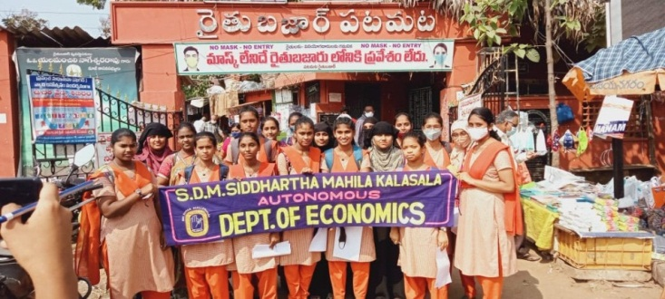
Students Survey by Farmers
