ENGLISH COMPETITIONS

The Literary Committee in association with the English Department, is conducted the following competitions on Friday afternoon 12-9-25 & Saturday 13-9-25 morning.

Fri-12/9-
1. Debate-1.30pm-
“Is technology turning people into zombies and less productive?”

2. Stand up comedy: 2.30pm- (about strangers, family, friends, Stereotypes, workplace, love life, social media etc.)

3. Pic speaks: 2pm to 2.30
About images displayed.

Saturday: 13/9

Essay writing: 10am-11am
“Impact of Trump’s immigration policies on Indian students and job seekers.”

Poster Presentation: 11am-12noon
“Causes of climate change and its impact on people.”

Role Play: 10am

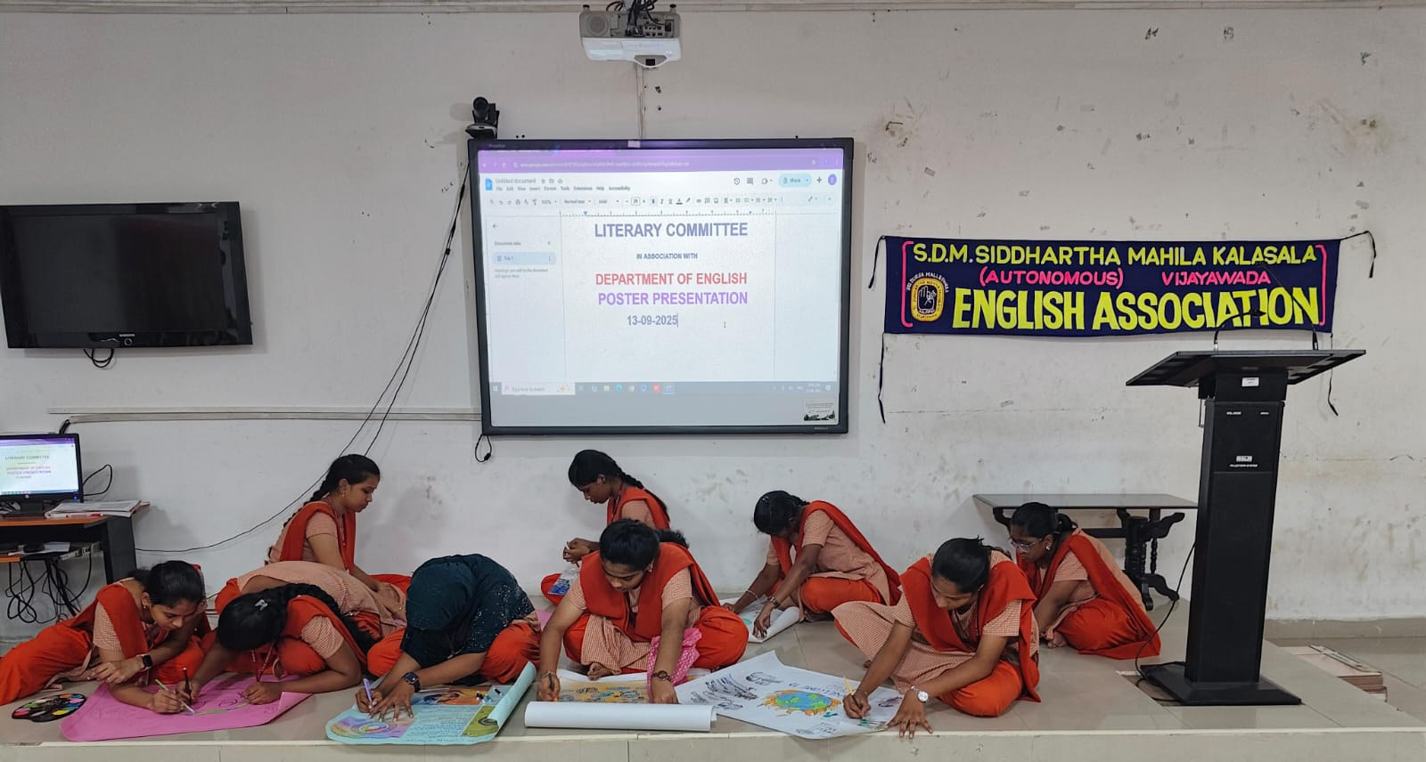

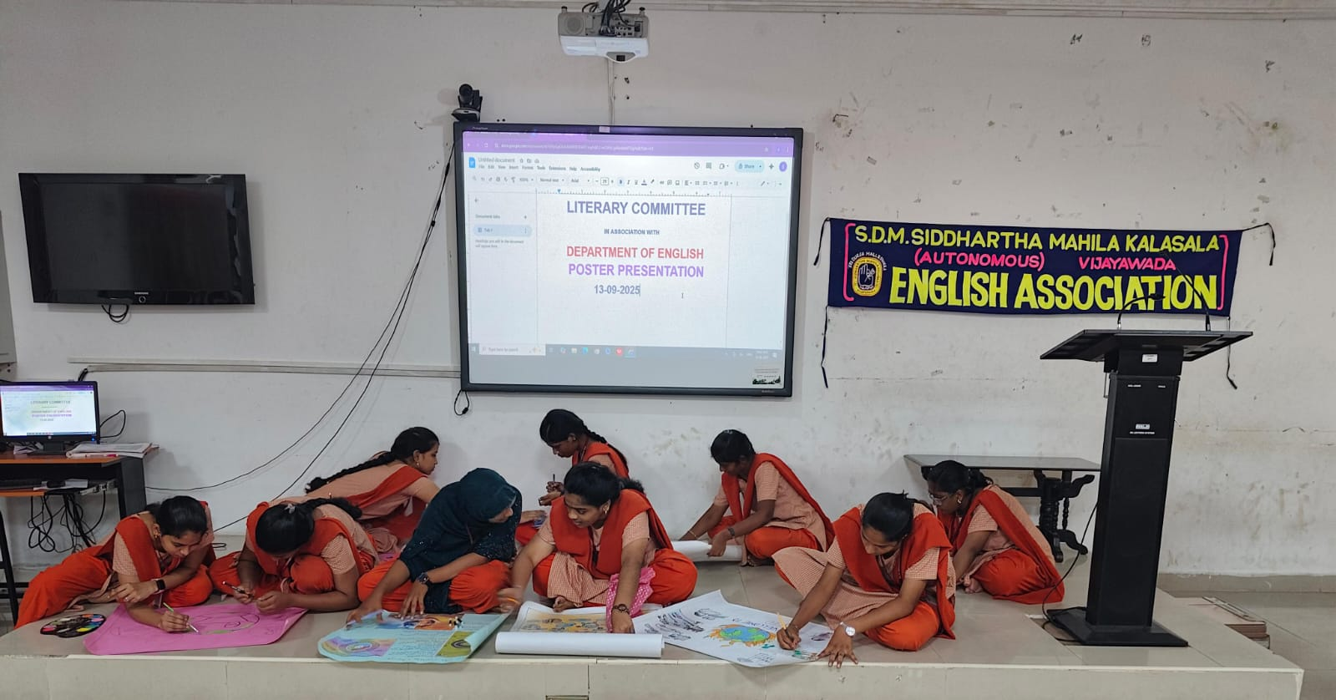

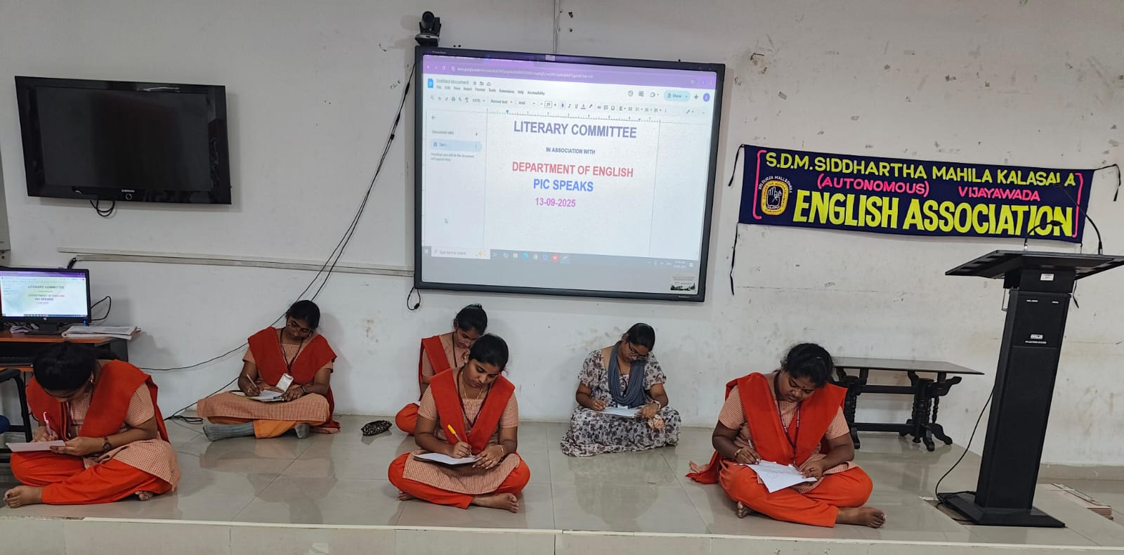

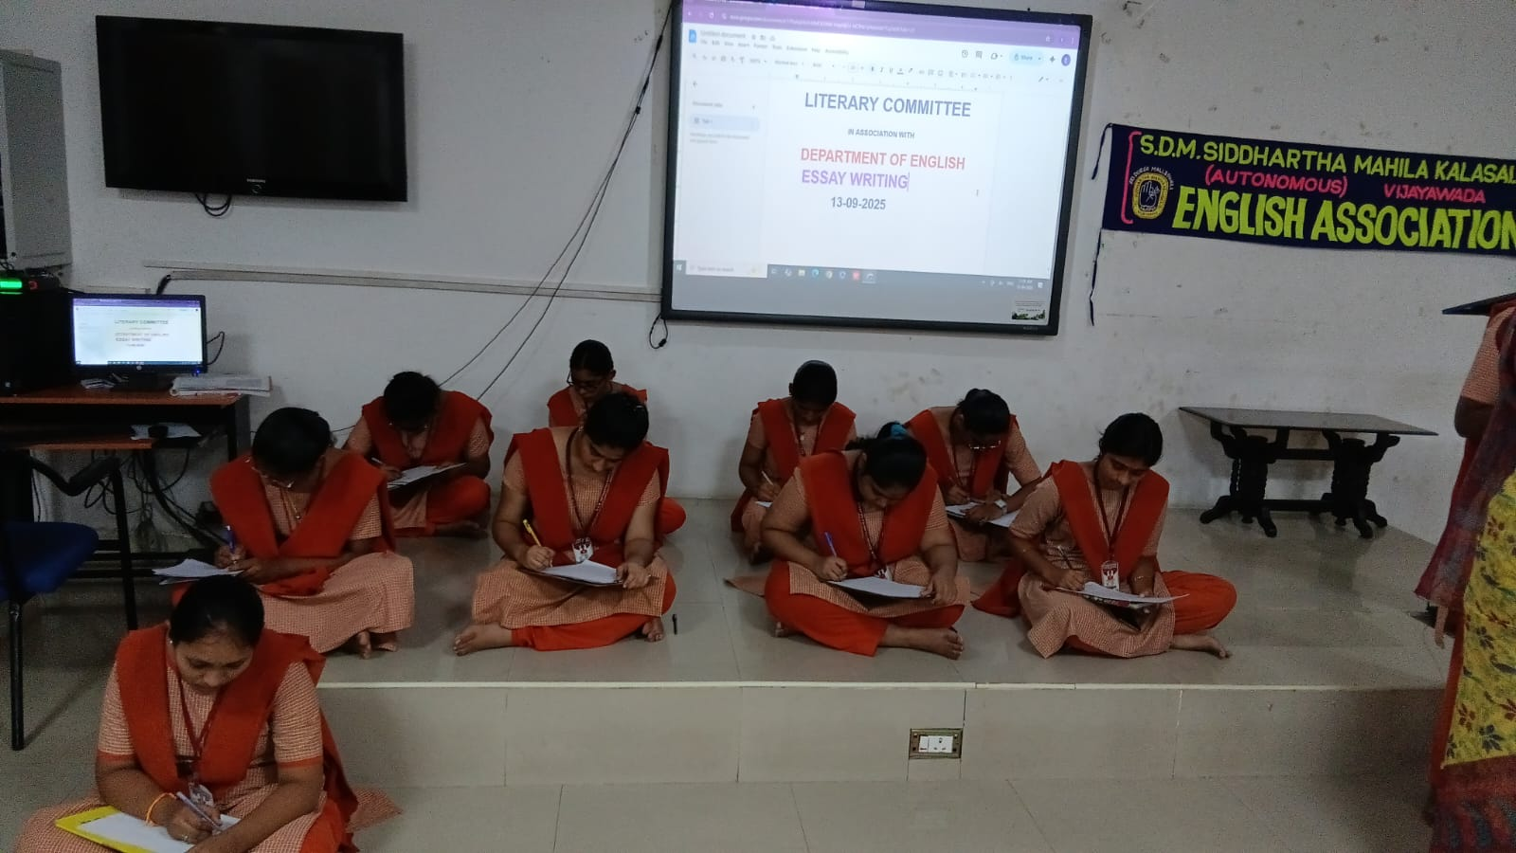

Prize winners of English Dept & LiteraryCommittee

Debate:
1. Md. Gousiya & A.M.M.Sankeerthana- III CSCS- I Prize
2. Md. Yasmeen II BCA & Leela Malleswari- III B. A
II Prize

Stand up Comedy:
1. B. Gita Naga Sree- IIIMicro-I prize
2. B. Himachandrika- III Micro - II prize
3. M. Sankeerthana -
III CSCS & Leela Malleswari- III B. A - II Prize

Pic Speaks:
1. J. Joshna-II B.Sc AI- I Prize
2. R.P. Pinky Kumari- III Micro
3. Md. Yasmeen II BCA

Essay writing winners:

1. J.Joshna II AI -1st prize
2. MD.Asmattunnisa- III Micro- 2nd prize
3. B.Susanna III B.A Pol sci-3rd prize.

Poster Presentation:
1. Md. Salma- III Micro- I Prize
2. Md. Ashrafunnisa-III B. A
II Prize
3. G. Yasaswini-III B. Sc Che-III Prize

Role Play:
1. Md. Gousia & team-III CSCS- I Prize
2. S. Jhansi Lakshmi- II B.A (Pol) & Team- II Prize
3. R. P. Pinky- III Micro & Team- III Prize

