“HINDI DAY CELEBRATIONS”
On occasion of Hindi Day, the Department of Hindi organized “Hindi Day Celebrations” on 11-9-2025 & 12-9-2025. The Department conducted competitions to the students in the following events and distributed prizes to the winners.
Date: 11-9-2025
Name of the event : Essay writing
Topic : Rastra Bhasha Hindi

Prize Winners:

I.Ch.Triveni - III Micro-Biology
II . Md.Asmathunnisa - III Micro-Biology
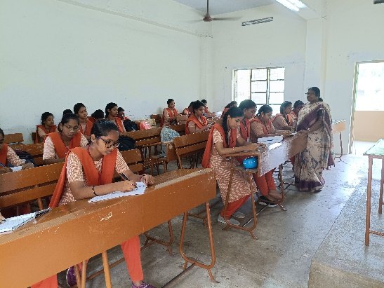
Name of Event : Elocution
Topic : Priya Kavi

Prize Winners:
I R.Pinky Kumari - III Micro-Biology
II . P.Ramya - I B.Sc/Computer
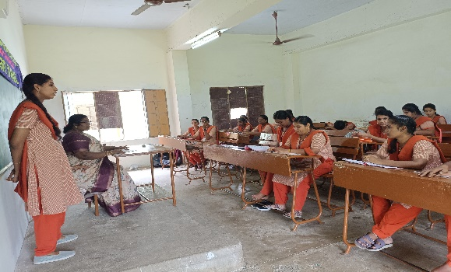

PRIZE DISTRIBUTION

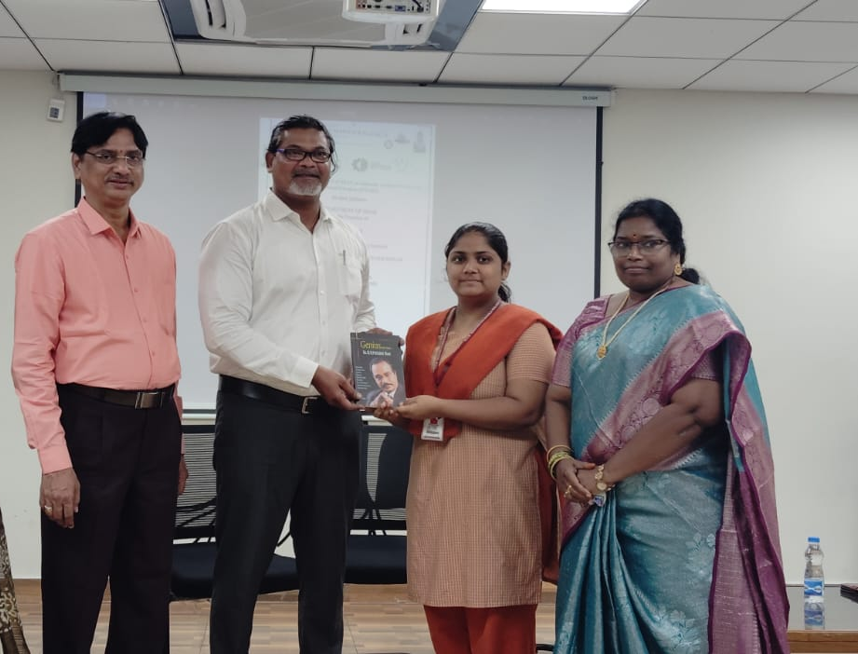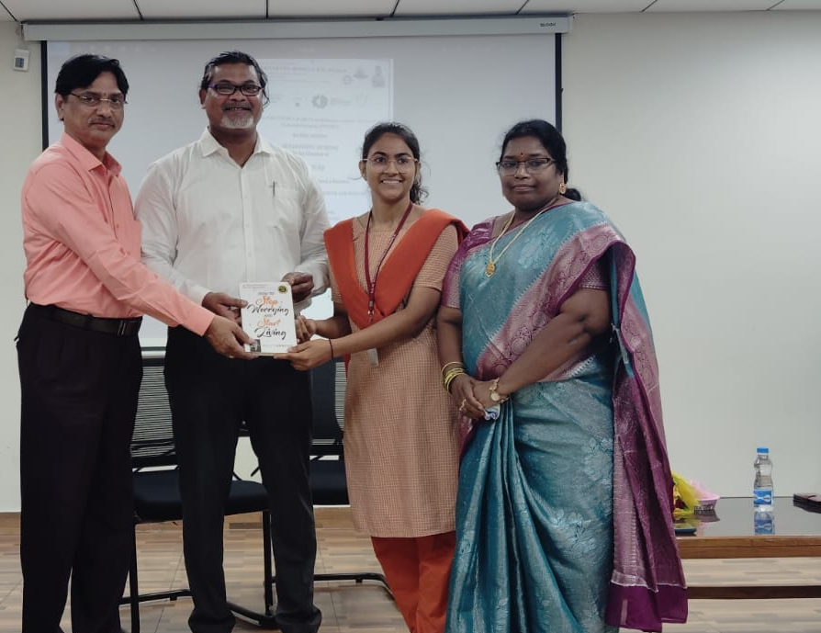

Enadu
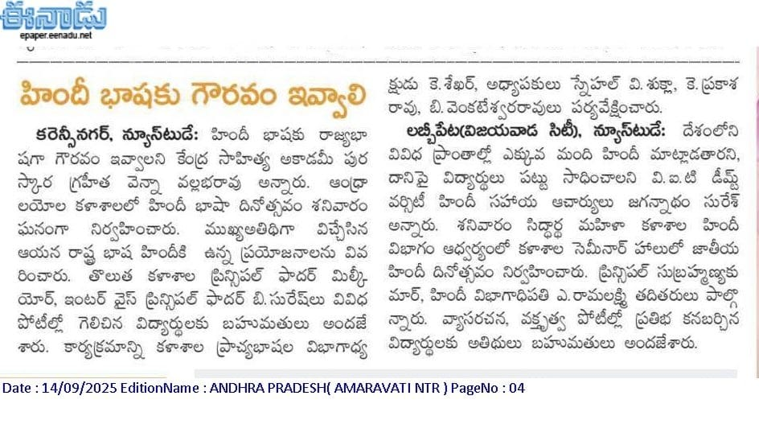

ANDHRA JYOTHI
