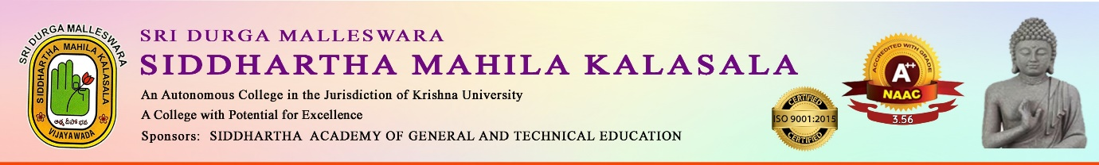

AN IQAC INITIATIVE
“ SANKRANTHI SAMBARALU”
Date: 09-01-2026
Participants:Degree & Inter Students
Description of the programme:
On the occasion of Sankranthi, the department of Telugu in collaboration with NSS Units celebrated “sankranthi sambaralu” Dr.V.V.S.Kumar - Principal, Dr.K.Sarala HOD & Dr.I.Manjula Lecturer, Dept of Telugu, NSS Programme officers Smt.T.Nagarani, P.Sri Bharathi actively participated in the event. Various competitions like Rangoli and Sankranthi Lakshmi were conducted and prizes were distributed to the winners.
