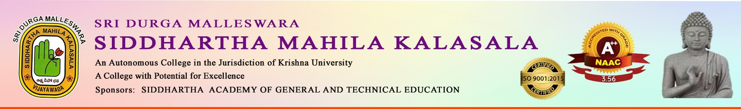
AN IQAC INITIATIVE
“ON THE OCCASION OF GITAJAYANTHI”
Date: 1-12-2025
Preamble: The Department of Telugu celebrated Gita Jayanthi
Chief Guest: Sri Valiveti Venkata Siva Ramakrishna Murthy
Participants: 250 Students of I Degree
Description of the Programme:
On the occasion of Gita Jayanthi the Dept of Telugu arranged a guest lecture on Gita Sandesam by Madhurakavi, Madhura Swara Yogi Sri Valiveti Venkata Siva Ramakrishna Murthy. Our Principal Dr.V.V.S.Kumar Garu, Dr.K.Sarala HOD and Dr.I.Manjula attended the programme.

