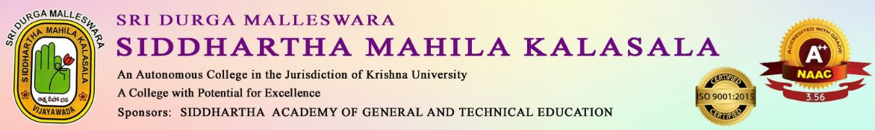

AN IQAC INITIATIVE
BOOK INAGURAL FUNCTION
Date :25-07-2025
Chief Guest : M.Hymavathi
Participants:120 students of ll Degree
The Depatment of Telugu Sri Durga Malleswara Siddhartha Mahila Kalasala organised a book release program.
The Department released the book titled “ENDLURI SUDHAKAR KAVITHA” authored by ENDLURI SUDHAKAR. MANDARAPU HYMAVATHI wrote forward for the book and was released by M. Hymavathi and Principal Dr.V.V.S.KUMAR on 25/07/2025.
Dr.K.Sarala HOD, Dept of Telugu, Dr.I.Manjula, Asst prof in Telugu and students participated in the program. The poets addressed the students on the occasion.
