AN IQAC INITIATIVE

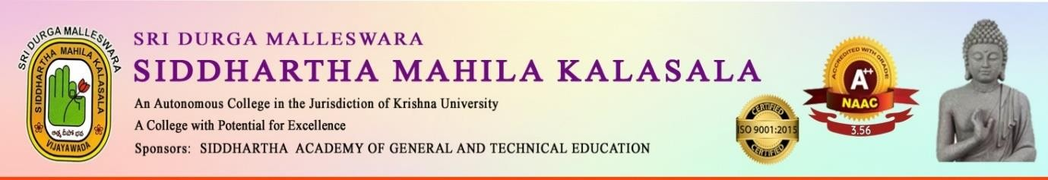
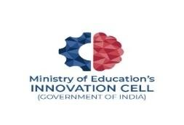
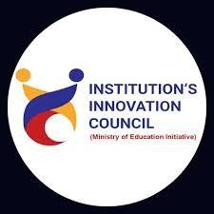
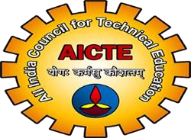
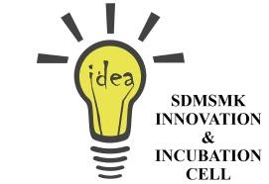


Department of English
Cordially invites you to
Student Induction Programme
On
“GRAMMAR REBOOT: ENHANCE YOUR LANGUAGE SKILLS”
By
Sr. Asst. Prof. Dr V. PAWEL
Vasireddy Venkatadri International Technological University
Namburu, Gunturu.
Venue: Webinar Hall
Date: 27th October 2025
Time: 10:30 AM - 12:30 PM

Dr. K. Sailaja Rani Dr.V.V.Subramanya Kumar
HOD Principal
STUDENT INDUCTION PROGRAMME

The Department of English organised a workshop on 27-10-25, on “Grammar Reboot: Enhance Your Language Skills “ by Dr Pawel Veliventi, Prof. of English, Vasireddy Venkatadri International Technological University, Namburu. from11am to 1pm . 200 Students from 1st year classes attended the workshop.

