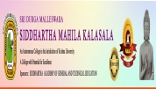
AN IQAC INITIATIVE
FIELD TRIP
Date : 10-07-2025
Department of Telugu, Sri Durga Malleswara Siddhartha Mahila Kalasala organised a Field Trip to Sri. Vijaya Raja Rajeswari Devi Ammavari Temple in Peddapulipaka on Date : 10-07-2025.
Dr.K.Sarala HOD Department of Telugu and Dr.I.Manjula, Asst.Proffesor along with 30 II & III year students participated in the field trip.

