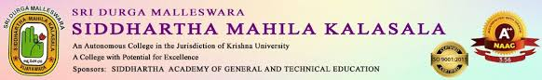
AN IQAC INITIATIVE
STUDENT INDUCTION PROGRAMME

In Commemoration of Golden Jubilee Celebration of, Siddhartha Academy, Inter Collegiate, Sri Durga Malleswara Siddhartha Mahila Kalasala and P.B.Siddhartha College of Arts & Sciences in collaboration with Mummaneni Subbarao Siddhartha Kala Pitam organised Yuva Kavi Sammelanam on 21-04-2025. Poetry Competitions were conducted to the students, Kum.G.Dharani from 1st Data Science and Kum.P.Vijaya Kumari of 1st B.A are felicitated.
Dr.S.Kalpana – Principal, Dr.K.Sarala HOD & Dr.I.Manjula lecturer Department of Telugu participated in the grand event.
