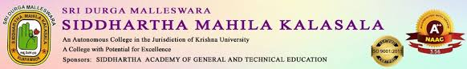
An IQAC Initiative
GUEST LECTURE ON PERSONALITY DEVELOPMENT

Date:25-06-2025
Resource Person : Dr.P.Vijay Kumar
Participants: 150 students of II Year Degree
Description of Programme:
The Department of Telugu, Sri Durga Malleswara Siddhartha Mahila Kalasala organised a Guest Lecture on “Personality Development” (Vyakthitva Vikasam) The Resource person of the event is Dr.P.Vijaya Kumar, Associate Prof. Dept. of Telugu, University of Hyderabad.
Principal Dr.V.V.S.Kumar, Dr.K.Sarala HOD & Dr.I.Manjula Ass.Proffesor, Department of Telugu participated in the programme. 