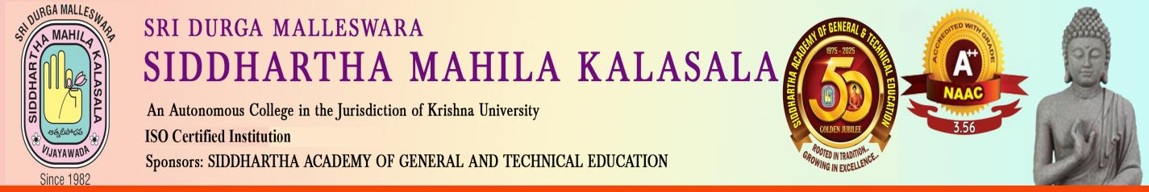
International Conference on “The Emerging Trends in Digital Humanities”
The Departments of Economics, Political science & History organized an International Conference, “The Emerging Trends in Digital Humanities” on 29th January, 2025.
The Conference was conducted under the guidance of Dr.S.Kalpana, Principal and Dr. R.Madhavi , the Special Officer, the Key Advisor. A total of 45 faculty members from various colleges in A.P., Telangana and the U.S.A. participated in the Conference bringing out varied insights in Digital Humanities. A Book of Proceedings was published with ISBN and 23 articles were published and indexed in a UGC Care List (Group I)Journal with ISSN. The Convenors of the Conference were Ms D. Aruna , Dr.M. Suneetha , Dr.G.Padmaja,and Ms Louis. coordinated the programme
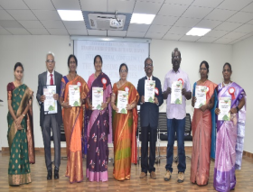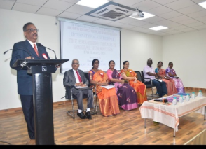

Felicitation to Honourable Guests
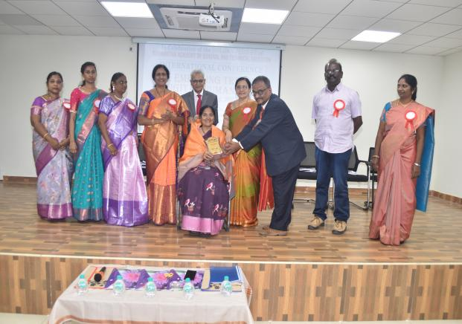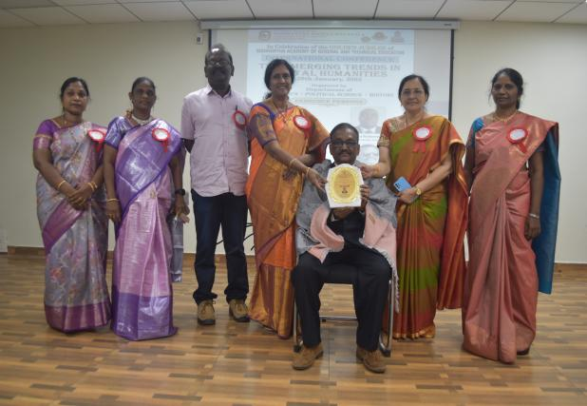
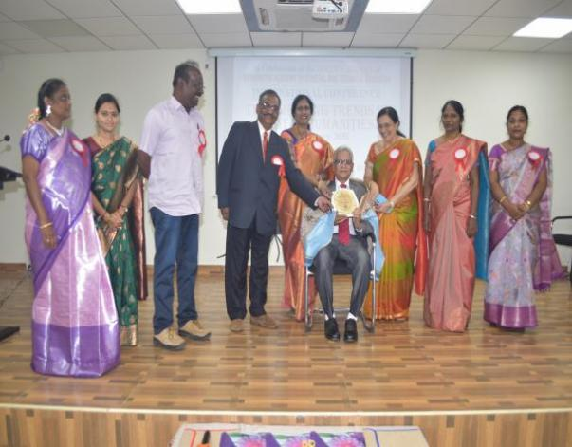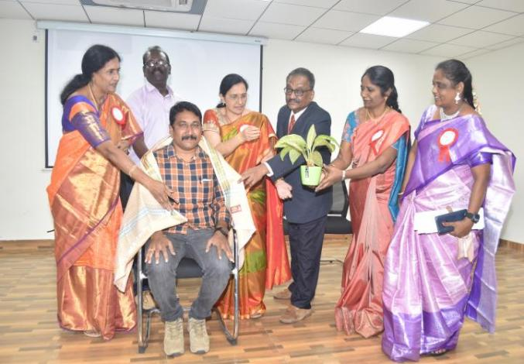
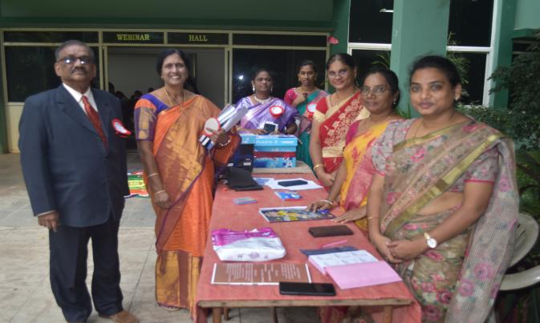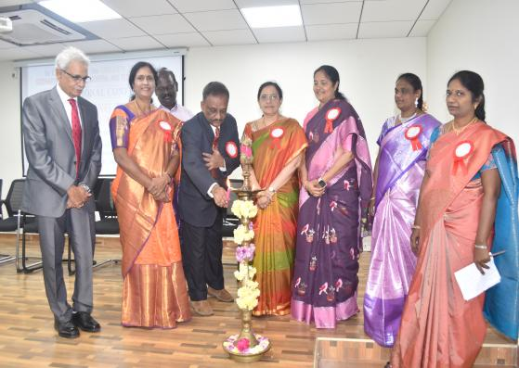

Distribution of Certificates (Paper Presentations)
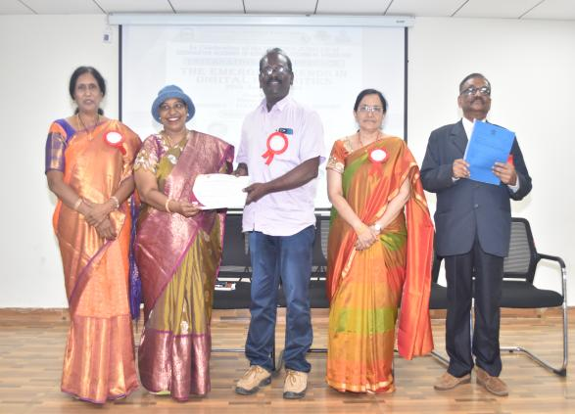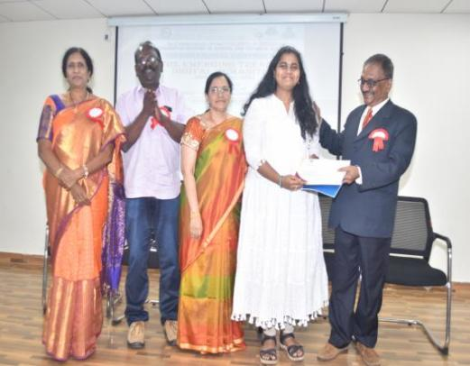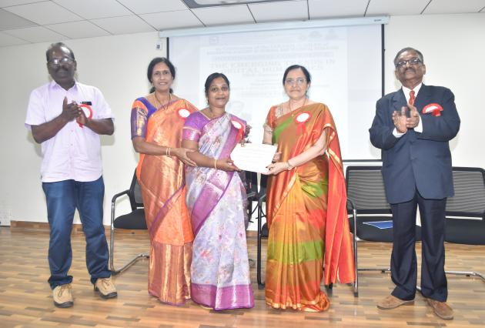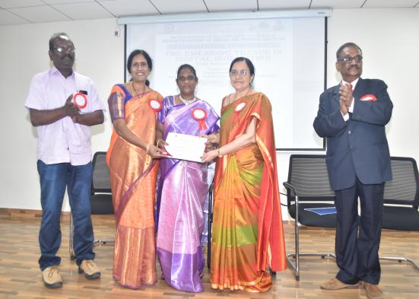

The Department of Political Science, Economics and History of Sri Durga Malleswara Siddhartha Mahila Kalasala, Vijayawada organized International conference on the "Emerging Trends in Digital Humanities on 29-01-2025". The Principal Dr. S. Kalpana presided and Dr. R. Madhavi co-ordinated the conference.
The inaugural session was graced by distinguished chief guest Mrs. V. Sasikala, Convenor of Siddhartha Nursing School and KCP Siddhartha Adarsh Public School delivered an inspiring address highlighting the significance of digital humanities in contemporary research. She also insisted to have humanistic approach in today's global corporate world. Following the inaugural session the first technical session was conducted by Prof. CSN Raju, Acharya Nagarjuna University, Guntur provided valuable insights into the evolutionizing of digitization in present era. He referred the problem of Y2K among the plethora of problems and manipulation of data.
The keynote speaker and guest of honour Prof. G.Kuppuram, Hon-Adjunct Prof, Mansinde, Munro, University of Science and Technology, Kenya stressed on the importance of digitalization, digital archives, directories and other new avenues in Digital Humanities. He related digital humanities with women perspectives and suggested that women should be aware of digital and viscious cyber crimes.
The second technical session was conducted online by an esteemed international resource person Prof. Murango Bernard from Somali Land who shared perspectives on digitization of project management, 3D printing, additive manufacturing. He introduced various opportunities and discussed the challenges.

The conference also included paper presentation session both offline and online modes. A total of 33 participants from 18 colleges in and around the city actively took part in the sessions, showcasing their research and engaged in meaningful discussions. The convenors of the event Dr. G. Padmaja, HOD Political Science, Ms. D. Aruna HOD Economics, Ms. Ria Jain HOD History, Asst. Profs Dr. M. Sunitha, Mrs. Louis actively participated in the conference. The event was successfully co ordinated with the co-operation of IQAC co-ordinator Dr.S.V.D Mohan Rupa and Chairpersons Dr.K.Sailaja Rani, HOD English, Ms. K. Sasi Dept of English SDM Kalasala.

