
Extension Activity Report: Visit to Bamboo Workers
1st-year BA (Honors) Economics& Political Science students, visit to the Bamboo Workers' Settlement on 18-02-2025 . This visit was part of our curriculum to gain practical insights into the livelihoods of workers engaged in traditional occupations and to understand the economic significance of such industries.
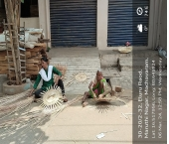
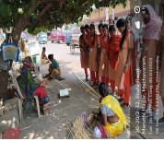

The primary objective of our visit was to engage with bamboo workers, learn about their experiences, and understand the intricacies of bamboo craft-making. We engaged in interactive sessions where the workers recounted their journey into the bamboo craft-making profession, highlighting the challenges they faced and the skills they acquired over the years.
