ADVITIYA 2024
Department of English organized, The Advitiya 2024 Inter Collagiate Competitions were held on a large scale on 21st October 2024 with over 256 students hailing from 18 institutions offering Pharmacy, Engineering, Arts, Science, Management Studies who participated in various categories Dr. T. Vijayalakshmi, former Director flagged off . The programme conducted under the aegis of the Literary Committee of the college and under the guidance of Special Officer Dr. R. Madhavi and coordinators Dr. K. Sailaja Rani and N. Saritha was planned and executed with great acumen and finesse. The categories thrown open to students included PPT Presentation, Poster Presentation, Short Film Making, Ad Film, College, Essay Writing, Elocution, JAM, Debate and Mr and Mrs Adivitiya. The prize winners for each category were awarded cash awards and certificates of participation were given to all participants of various categories.
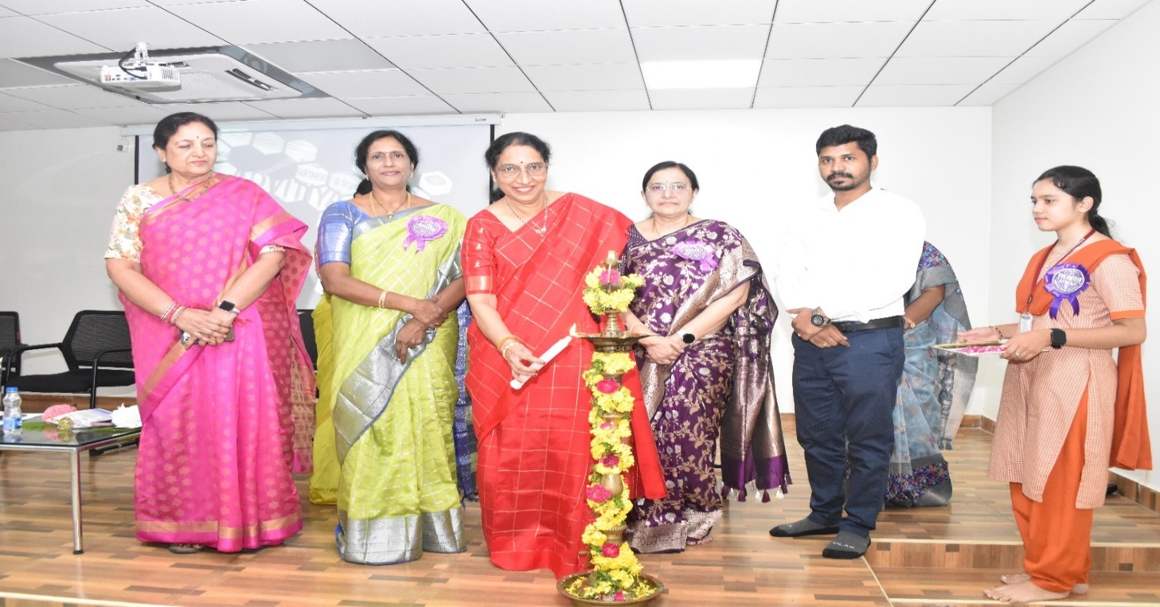

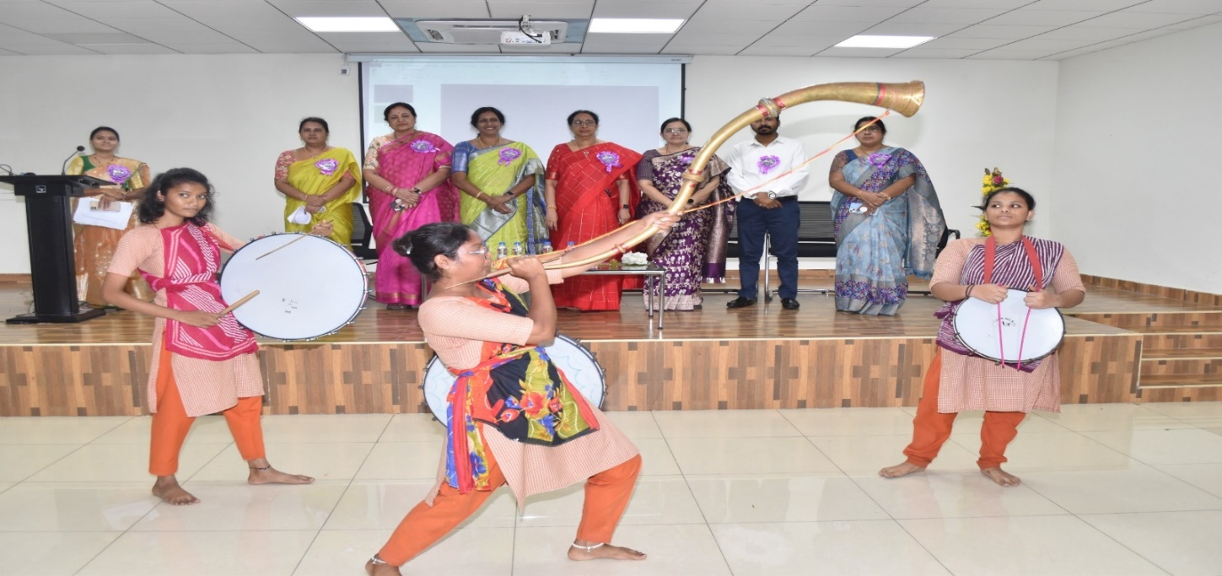
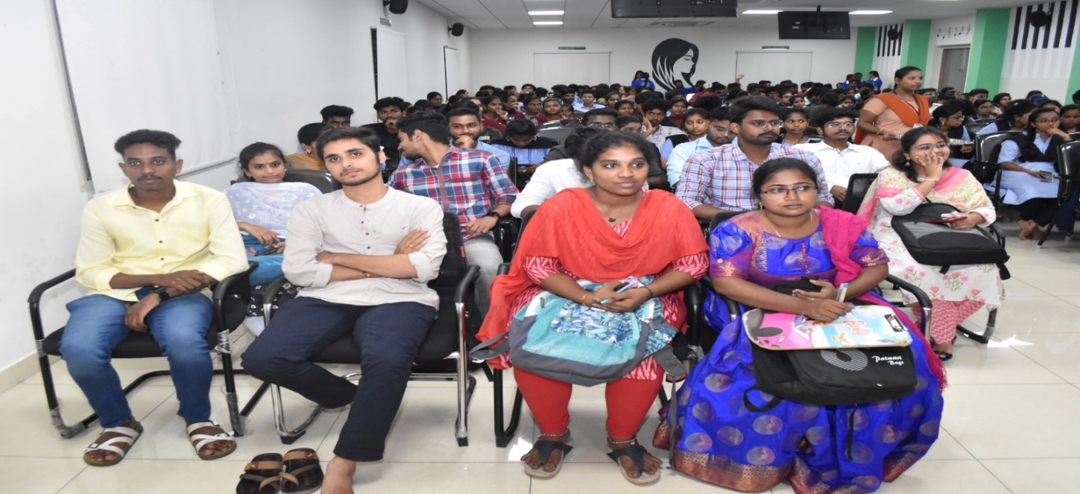

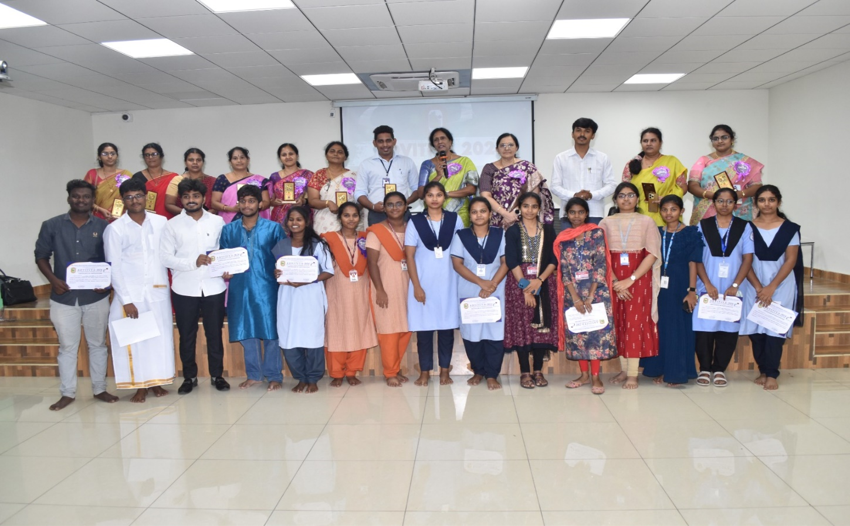

The Cash Awards were generously sponsored by the Speaking Tree Institute, while the mentors were supported by Satyam Academy. The certificates were provided by Writers' Voice. The event's resounding success was made possible through the collective efforts of the coordinators, judges, and the enthusiastic participants, who together showcased remarkable talents and communication skills.

