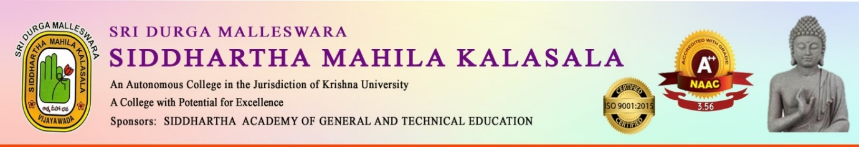
A ONE- DAY INTERNATIONAL WORKSHOP
on
AI TOOLS TO IMPROVE ENGLISH WRITING SKILLS
AN FDP FOR TEACHING AND NON – TEACHING STAFF
organised by
DEPARTMENT of ENGLISH
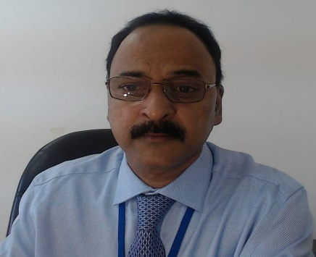

Resource person: VASIREDDY MURALI KRISHNA
HOD, Curriculum University of
Technology and Applied Sciences,
Salalah, Oman.

Date: 2nd August 2024.
Time: 10:00AM - 4:00PM
Venue: Webinar Hall

AN IQAC INITIATIVE

Dr. K. Sailaja Rani Dr. R. Madhavi Dr. S. Kalpana
HOD, Dept of English Special Officer Principal

FACULTY DEVELOPMENT PROGRAMME

A One Day International Faculty Development Programme on “AI Tools to Improve Writing Skills” wasorganized by the Department of English in Collaboration with Department of Computer Science of SDMSM Kalasaala, Vijayawada on 3rd August, 2024 from 10am to 1Pm at Webinar Hall.

Sri Vasireddy Murali Krishna, HOD, Curriculum University of Technology and Applied Sciences, Oman was the Resource Person.

The programme was aimed to equip faculty members with the latest Artificial Intelligence tools to enhance their Writing Skills and stay updated with the latest trends in AI-Powered Writing.

