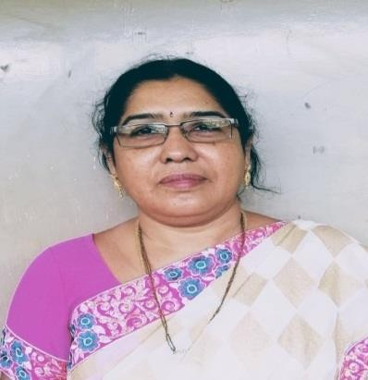PROFILE

Dr.K.SAILAJA RANI
311-Block B, Siri Jewel,
Gottipati Bramaiah street, Ayyappanagar, Vijayawada-520007.
e-mail: saimadhu31@gmail.com Mobile No:9396558009

QUALIFICATIONs : M.A, M.Phil, PH.D from Andhra University.
TEACHING EXPERIENCE : 35 YRS

EXPERIENCE SUMMARY:
- Worked as a lecturer in English Department in Vignan Residential JUNIOR College,from 1986-1988.
- Worked as a lecturer in English Department in KTR College for Women,Gudivada from1988-89.
- Working as a lecturer in English department in Sri Durga Malleswara Siddhratha Mahila kalasala from November, 1989 to till date.
- PUBLICATIONS: 4+6=10
- NATIONAL SEMINARS: 10
- INTERNATIONAL SEMINARS:5
- WORKSHOPS: 10
- FDPS: 2

PUBLICATIONS:
- Published a paper on Assertion of Self in the Select Novels of Sasi Deshpande and Chitra Benarjee, Divakaruni journal of Research ISSN No: 2236-6124 with impact factor : 5.7 & ISO: 7021-2008.
- The research article on Spiritual Sense of Alienation: Bharati Mukherjee’s Novels (P: 223) was published in the book on New Trends in Indian
English Literature with ISBN : 978-93-82186-51-9 published by the Department of English, S.D.M.S.Mahila Kalsala, Vijayawada.
- Smt.K.Sailaja Rani, Lec in English was awarded M.Phil from Madurai Kamaraj University, Madurai on Migration, Immigration and Alienation- In the Novels of Bharathi Mukharjee.
PAPERS:
- 1. The Effect of Trauma in Shobhan Bantwal's Novel The Dowry Bride by K.Sailaja Rani & Dr. S.Prasanna Sree
- 2. Gender Inequality in The Forbidden Daughter of Shobhan Bantwal by K. Sailaja Rani &
- Dr. S. Prasanna Sree
- 3. Chuckling Tears on the Cheeks of Sand dunes: Understanding Helen Benedict's Novel Sand Queen
- 4. Courage is Resistance to Fear: Evaluating Baby Kamble's The Prisons We Broke by K.Sailaja Rani & S Prasanna Sree
- 5. Inquest of Freedom and Choice: Maaza Mengiste's Beneath the Lion's Gaze by K.Sailaja Rani & S. Prasanna Sree
- 6. Search for Paradise within and Out: Glimpses on Abdulrazak Gunrah's Paradise by K.Sailaja Rani & S. Prasanna Sree

ADDITIONAL INFORMATION:
- Had attented Train the Trainer Workshop organised by APSCHE and British Council. As a Master Trainer have been training the students for placements and employability.
- Have been Examiner for many Colleges.
- Have framed Syllabus for general English for I&II
- Acted as Adjudicator
- Participated in organising various Seminars and Workshops.
- Acted as a Resource Person.

COMMITTEES HANDLED:
- PREPARED WRITEUPS FOR NAAC REPORTS
- MEMBER OF MAGAZINE FOR 5 YEARS
- CONVENOR OF MAGAZINE FOR 6 YEARS
- MEMBER OF NEWS LETTER FOR 1 YEAR
- COVENOR OF NEWS LETTER FOR 2 YEARS
- CONVENOR OF CALENDER 2 YEARS
- MEMBER OF INTERNAL EXAMINATION CELL FOR 4 YEARS
- CONVENOR OF STAFF CLUB FOR 1 YEAR
- CONVENOR OF COLLEGE COMPEERING COMMITTEE FOR 5 YEARS
- CONVENOR OF COLLEGE RADIO 1 YEARS
- CONVENOR OF PRESS RELATIONS FOR 2 YEARS
- CONVENOR OF HOUSE JOURNAL FOR 6 YEARS
- IN-CHARGE OF ENGLISH LAB FOR 5 YEARS
- CONVENOR ANNUAL REPORT & HOSTEL REPORT
- MEMBER OF IQAC FOR 2 YEARS.

ONLINE WEBINARS, FDP’S , QUIZ , COURSES:

- WEBINARS - 30
- FDP,S - 4
- QUIZ - 24
- COURSES - 3

