PROFILE 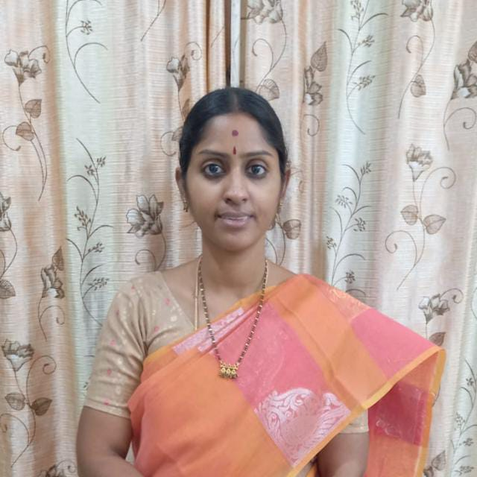

SAKSHICHERULA HINDOLA (MA, M. ED)
DEGREE LECTURER IN ENGLISH
SRI DURGA MALLESWARA SIDDHARTHA MAHILA KALASALA
VIJAYAWADA
Mobile No.: +91 8142022322
sakshihindolakarthik@gmail.com

QUALIFICATIONS:

- 10th Std passed with 70% from Kumar Public school, Nuzvid in 2005
- Intermediate passed with 79% from MVR College, Nuzvid in 2007
- Bachelor of Arts (History) passed with 60% from Sri Sathya Sai University in 2007-2010.
- Bachelor of Education (English and Social) passed with 75% from Krishna University in 2010-2011
- Masters in Arts specialised in English passed with 60% from DAR College (Affiliated to Acharya Nagarjuna University) in 2011-2015.
- Masters in Education specialised in English and Social passed with 75% from Vikas College (Affiliated to Krishna University), Vissannapeta during 2016-2018.

EXPERIENCE:
- At Trividha High school, Nuzividu. 2011-13:
- Handled classes of 7th and 8th standards for English and social.

EXTRA CURICULAR ACTIVITIES:

- Music teacher at home

