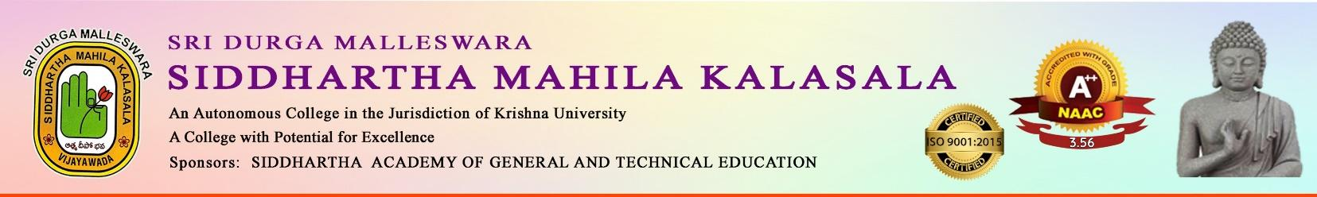
An IQAC Initiative

DEPARTMENT OF HINDI
On the Occasion of

HINDI DAY

Cordially Invite You to Guest Lecture
On
HINDI UDBHAV AUR VIKAS

By

Prof. G. PADHMAVATHI,
D.B.H.P.S, Shiksha Mahavidyalay
(Print, Vision-Coordination)
VIJAYAWADA.
On
14th September, 2024
Venue: e-class room
Time: 12:00 PM

- Rama Lakshmi, HOD Dr. R.Madhavi Dr. S. Kalpana
Dept. of Hindi Special Officer Principal

GUEST LECTURER ON
HINDI UDBHAV AUR VIKAS
DATE: 14-09-2024
RESOURCE PERSONS: 1. Prof. G. Padhmavathi,
D.B.H.P.S, Shiksha Mahavidyalay,
VIJAYAWADA.
Description of the Program:
Prof .Padhmavathi enlightened the students about the Hindi Sahithya Vaibhav . She encouraged to develop the creativity of sahithya in Hindi language .She described the inner meaning of the sahithy and how Hindi language is helpful to bring the Independence and social development.
Prof. G. Padmavathi delivered Lecture
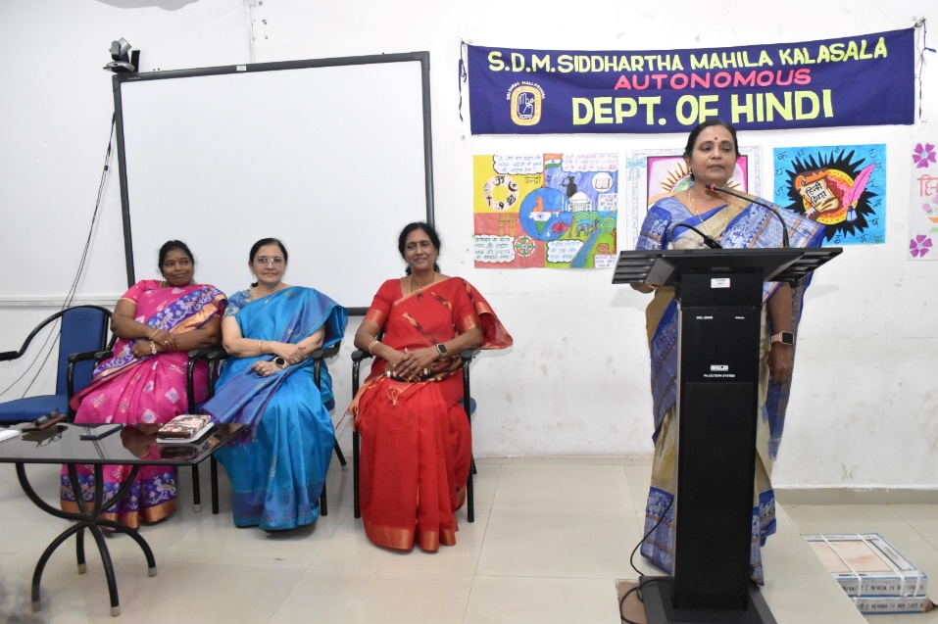
Eenadu
