BEST PRACTICE
It is the best practice of the department to celebrate Hindi Day on 14th September and conduct various competitions every year.
2024-2025
- Conducted an Essay Writing competition on “Rastra Bhasha Hindi” and Sk.Farheen Sulthan I B.Com/B2 got I prize, P.Ramya secured bagged II Prize in it.
- Conducted Elocution competition on “Priya Kavi” and Md.Gousia Begum II CSCS got I Prize, Sk.Sabiha I B.Com/B2 received II Prize.
- Conducted JAM competition on “Sirf Hindi Mey” and Aisha I Physics secured I Prize, G.Mounika I Botany got II Prize.
- Conducted Doha Pattan competition and N.Nikhitha I A.I got I Prize, Sd.Mastan bee I B.Com/Banking and Insurance bagged II prize.

Elocution Doha Pattan
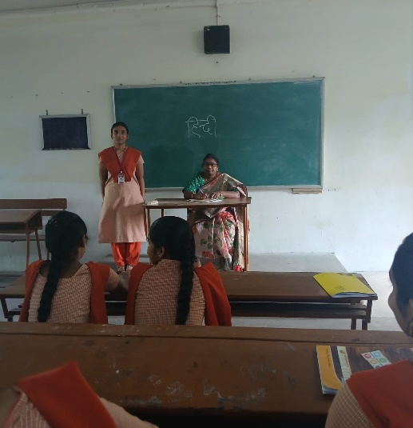
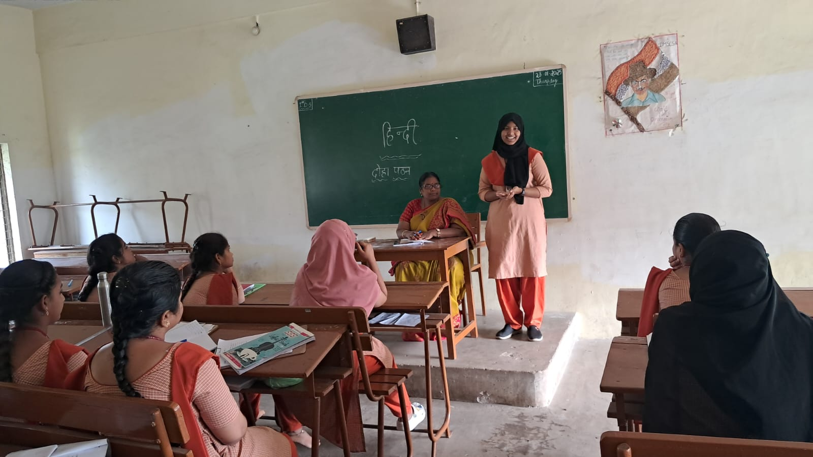
2023-2024
- Conducted an Essay Writing competition on “Rastra Bhasha Hindi” and T.Kasi Nandini I FST got I prize, P.Ramya I Computers/B secured bagged II Prize in it.
- Conducted Elocution competition on “Viswa Bhasha Hindi” and R.Pinky Kumari I Micro got I Prize, Y.Satya Deepika II B.Zc received II Prize.
- Conducted JAM competition on “Sirf Hindi Mey” and P.Samreen II FMC secured I Prize, Md.Asmathunnisa I Micro got II Prize.
- Conducted Doha Patan competition and D.Nohidha Bhanu I MCCS got I Prize, A.Arya Sri Varshini I CSCS bagged II prize.

Essay Writing

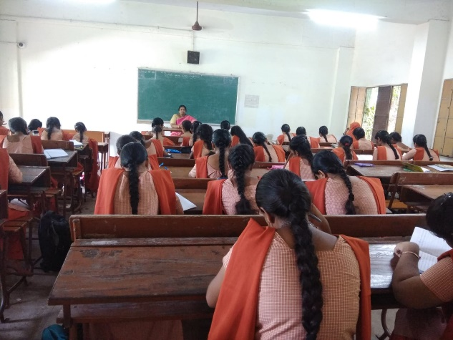

Elocution
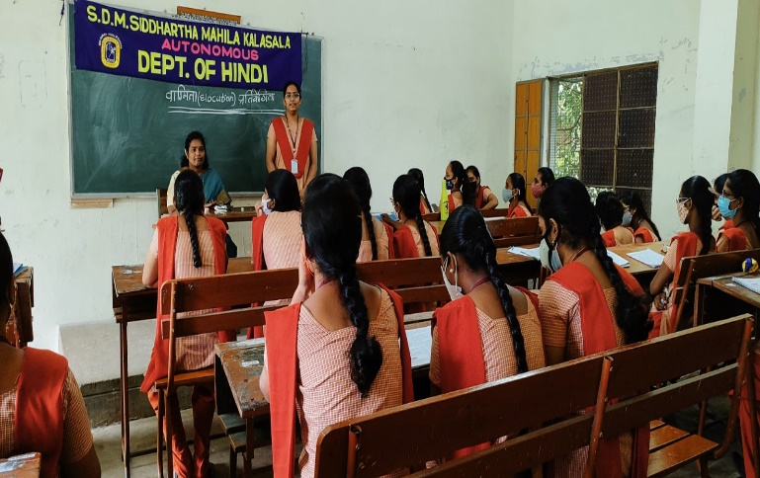

Prize Distribution

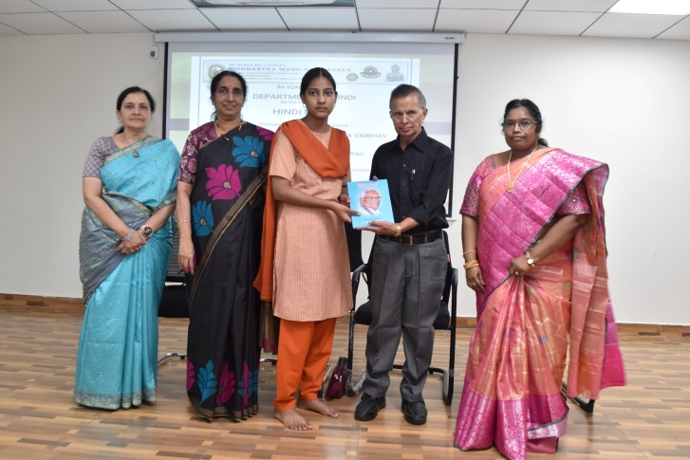

2022-23
- Conducted an Essay Writing competition on “Nari ka Mahtav” and K.Chandana II B.A secured I Prize, K.Srivalli II FMC secured IIPrize, K.Chaturya II B.Com/B secured III Prize.
- Conducted Elocution competition on “Beti Bachao , Beti Padao” and Ch.Saillu II FMB secured I Prize, Sk.Nelofer II B.Com/B secured II Prize, Md.Allimunnisa I MCCS secured III Prize.
- C
- Conducted Doha Patan competition on B.Sowmika II MCCS secured I Prize, Sy.Nassimunnissa II B.A secured II Prize, B.Madhumitha II MSDS secured III Prize.

2021-22
  - In Essay writing on “Sahity aur Samskruti” Y.Sushma, II B.Com/B won I prize & S.Indhusri, I B.Com/D won II prize, K.Anitha - II MCCS secured III prize and R.Sarada II MCCS won Consolation prize.
  - Conducted Elocution competition on “Aachary Ramchander Shukal” and Puja Sihag –I MSCS/B secured I Prize, R.Lakshmi Durga I MSCS/B secured II Prize, M.Rajeswari – I B.Com/Bbagged III prize.
  - Conducted an Poster Presentation competition on “Purane aur Naye Kavi” and S.Indu Sri I B.Com/D secured I Prize, M.Saturika I FMC secured II Prize, P.Sucharitha I B.A secured III Prize.
  - Conducted an Doha Pattan competition and Hema priya I FMC secured I.Prize, D.Vijaya Swetha – I BBA secured II Prize, Amreen Kousor I MSCS/B secured III Prize.
  - Conducted JAM competition on “Sirf Hindi Mey” and S.Dihitha I MSCS/A secured I Prize, S.Sneha Latha I BBA got II Prize,G.Sushma Sri I FMC secured III prize.

