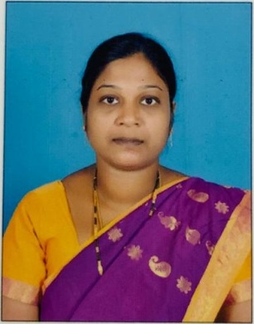
PROFILE

Dr. M.SUNEETHA
Lecturer, Dept. of Economics
Qualification: MA, B.Ed, Ph.D.
Experience: 3 Years
3 Years in Maris Stella College, Vijayawada
Working as a Faculty in SDMSMK, Vijayawada.
E-mail id: suneetha2010m@gmail.com

Academic Profile

COURSE | NAME OF THE INSTITUTION | YEAR OF PASSING | PERCENTAGE OF MARKS
Ph. D(Economics) | Acharya Nagarjuna University, Guntur. | 2023 | Awarded 16-11-2023
MA ( Economics) | Maris Stella College, Vijayawada | 2003-2005 | 61
B.ED (Social&English) | Krishna University, Machilipatnam | 2019-2021 | 62%
BA (Economics) | Maris Stella College, Vijayawada | 2000-2003 | 55%
INTERMEDIATE | Maris Stella College, Vijayawada | 1998-2000 | 54%
10th Class | ZP High School, Vijayawada | 1998 | 57%

Achievements:

Awarded Doctorate in 2023 for my Research and have attended national and international seminars given several paper presentations on woman investors in Coastal Andhra Pradesh

Subjects Handled:

- Insurance Services
- Economic Thought and Political Economy
- Public Economics
- Fundamentals of Economics

Publications:

- Published for UGC Care Journals Suneetha Munnagi(2022) Awareness Levels Among The Women Investors towards Investment Avenues-An Emperical perspective in International Journal of Management Technology and Engineering ISSN NO 2249-7455,IJMTE Journal,VOL XII,ISSUEX,Oct22
  - Published for UGC Care Journals Suneetha Munnagi(2023) Economic Analysis On The Investment Status of Women Investors in Guntur district UGC Care group Journal ISSN-2347-3150 Mukt shabd Journal Volume Xll,January2023

Workshops/ Seminars/FDP Organized/Attended:

- Paper presented and participated in the ICSSR sponsored two day National Seminar on An impact of Development programes for social transformation of scheduled castes scheduled Tribes paper entitled Tribal Women in Agriculture &Work Participation during 29th & 30th November 2019 organised by Department of commerce & Management, KBN College (Autonomous) Vijayawada, A.P.
- Paper presented and participated in two day International seminar on Strategies for Transforming India-The Way Forward paper entitled “Female Labour Force Participation in India” during 18th&19th December 2019 organised by Department of Commerce & Management K.B.N College (Autonomous) Vijayawada.
- Paper presented & participated in two day National seminar on Agricultural Growth In Indian Economy- Regional Experiences and Policies entitled Women Entrepreneurs in the Indian Agricultural sector organized by Department of Economics, Acharya Nagarjuna University on January 24th&25th 2020 at Acharya Nagarjuna University Guntur A.P.
- Paper presented & participated in two day national seminar on 75 years of Indian Economy-Economic Growth and Distributive Justice entitled Service Sector Its Performance & growth in India organized by Department of economics Acharya Nagarjuna University on 9th&10th March 2023.
- Paper presented & participated in two day National Seminar on Advanced Technology in Agricultural Sector in India: challenges & strategies – with special Reference on Andhra Pradesh entitled The Roll of Infrastructure in Agriculture Development its Importance & Road Infrastructure Development in India organized by Department of Economics, Acharya Nagarjuna University, Guntur, A. P.

