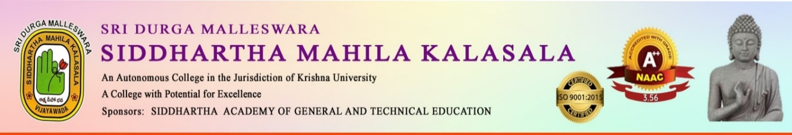

A ONE- DAY INTERNATIONAL WORKSHOP
on
COMMUNICATIVE ENGLISH IN THE 21ST CENTURY
organised by
DEPARTMENT of ENGLISH
Resource person: Dr. P. Charles
ELT Expert, Odessa, Texas, USA.

Date: 9th August, 2024
Time: 10:00AM - 12:00PM
Venue: Webinar Hall
For: II and IIIrd year students

AN IQAC INITIATIVE

Dr. K. Sailaja Rani Dr. R. Madhavi Dr. S. Kalpana
HOD, Dept of English Special Officer Principal

ONE DAY INTERNATIONAL WORKSHOP
A One-Day International Workshop titled "Communicative English in the 21st Century" was conducted by Department of English Siddhartha Mahila Kalasala on 9th August, 2024 for 2nd year Students
The workshop was conducted by Prof. P. Charles from Odessa, Texas, USA, a distinguished expert in the field of Communicative English.
Prof. Charles presented insights and techniques into effective communication strategies comparing those used to train Mexican learners back in the USA and those needed to be used for Indian learners that are essential for success in both academic and professional environments.
In conjunction with the workshop, the college launched the "Speak English Drive," a campus-wide initiative aiming to promote better spoken English skills among students. The drive kicked off with oath taking and a rally, where students and faculty came together to emphasize the importance of effective communication in English.
