“HINDI DAY CELEBRATIONS”
On occasion of Hindi Day, the Department of Hindi organized “Hindi Day Celebrations” on 8-9-2024 & 12-9-2024. The Department conducted competitions to the students in the following events Essay writing, Elocution, JAM and Doha pattan, distributed prizes to the winners.

Date: 08-9-2024
Name of the event : Essay writing
Topic : Rastra Bhasha Hindi

Prize Winners:

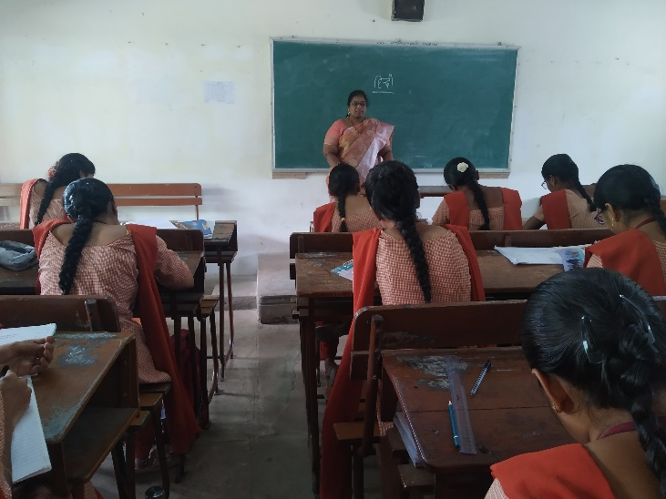

Name of Event : J.A.M
Prize Winners:

I P.Samreen - II FMC
II Md.Asmathunnisa - I Micro
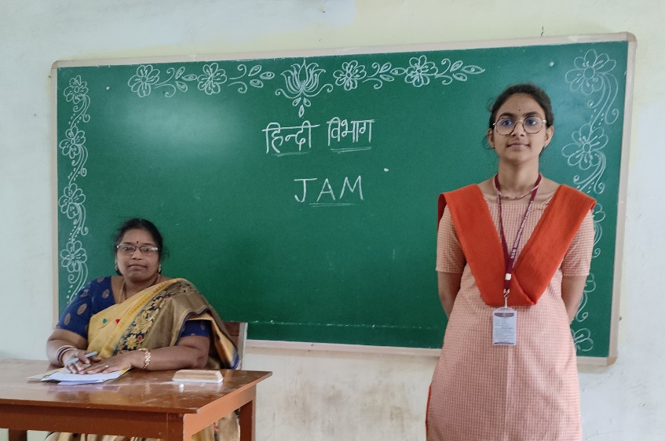

Date: 12-9-2023
Name of Event : Dhoha Pattan
Prize Winners:

I D.Nohidha Bhanu - I MCCS
II A.Arya Sri Varshini - I CSCS

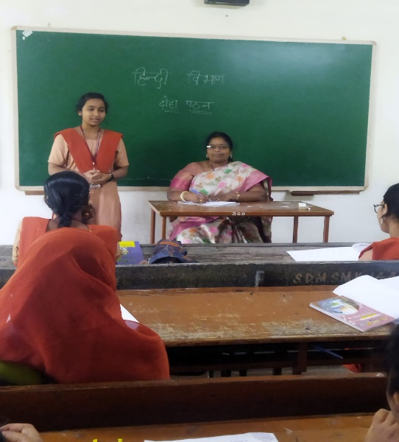

Name of Event : Elocution
Topic : Viswa Bhasha Hindi

Prize Winners:
I R.Pinky Kumari - I Micro
II Y.Satya Deepika - II BZC
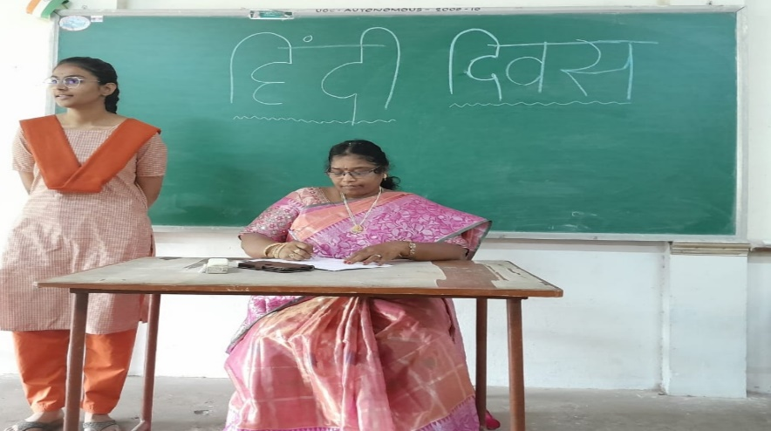

PRIZE DISTRIBUTION

