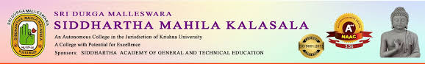

AN IQAC INITIATIVE
FIELD TRIP
Date: 5/11/2024
The Department of Hindi in Collaboration with Department of Telugu arranged a Field Trip to Venkatapuram, Venkatayapalem, Tallaipalem, Anantharam and Undavalli Caves on the occassion of Karthika Masam.
Faculty of both the Departments Dr.K.Sarala, HOD, Telugu Department, Dr.I.Manjula, Asst.Prof of Telugu Department and A.Ramalakshmi, HOD, Hindi Department along with thirty students participated in the Field Trip. Through this event every student experienced real world learning.

