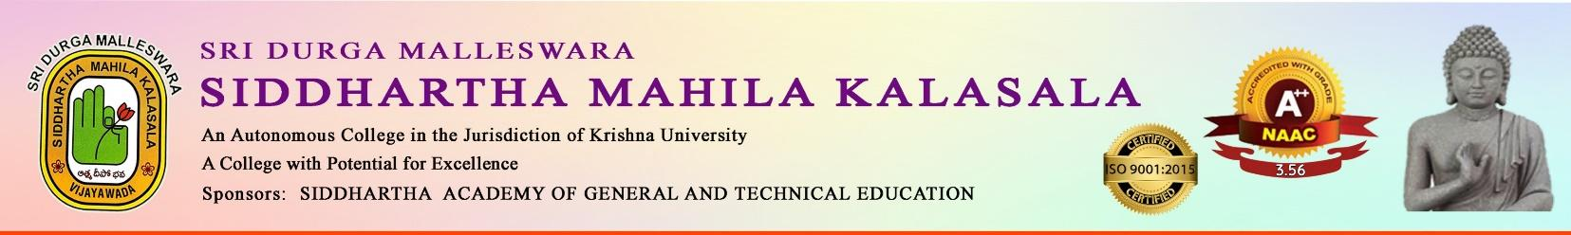
An IQAC Initiative

DEPARTMENT OF HINDI
On the Occasion of

HINDI DAY

Cordially Invite You to Guest Lecture
On
BHARTH KI EKTHA-HINDI SAHITHYA VAIBHAV

By

Prof. Bhairavabhatla Narayana Rao,
Founder,Director of
“Bhairavabhatla Narayana Rao” Film Research Center,
(Print, Vision-Coordination)
Great Poet & Critic, Researcher of Film Songs, Hyd.
On
14th September, 2023
Venue: Webinar Hall
Time: 2:15 PM

- Rama Lakshmi, HOD Dr. T. Vijaya Lakshmi Dr. S. Kalpana
Dept. of Hindi Director Principal

GUEST LECTURER ON
BHARTH KI EKTHA-HINDI SAHITHYA VAIBHAV
DATE: 14-09-2023
RESOURCE PERSONS: 1. Prof. Bhairavabhatla Narayana rao,
Founder, Director of ”Bhairavabhatla Narayana Rao”
Film Research Center,Hyderabad.

Description of the Program:
Prof .Bhairavabhatla Narayana Rao enlightened the students about the Hindi Sahithya Vaibhav . He encouraged to develop the creativity of sahithya in Hindi language .He described the inner meaning of the sahithy and how Hindi language is helpful to bring the Independence and social development.
Prof. BHAIRAVABHATLA NARAYANA RAO , PRIZE DISTURBUTION
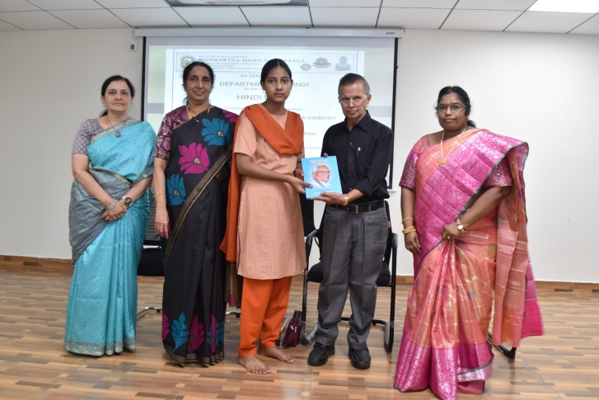
FELICITATION Prof. BHAIRAVABHATLA NARYANA RAO
