MUSHROOM CULTIVATION WORK SHOP

DATE:12-3-2024
Resource Person: Sri T. Jayachand
No.of students participated:30
Staff and students of IIBZC attended a work shop on “Mush room Cultivation” organized by PBS College of Arts & Science in association with Rotary Club. The Resource person Sri T. Jaya chand explained Commercial cultivation technology of Button, Oyster, Milky, Shiitake, Nutritive and medicinal properties, post- harvest packaging and management, Marketing, Machinery, and equipment for mushroom farm, farm layout, Disease and pest management, Sanitation & food safety in the mushroom farm . He also explained how to identify poisonous mushrooms from edible mushrooms.

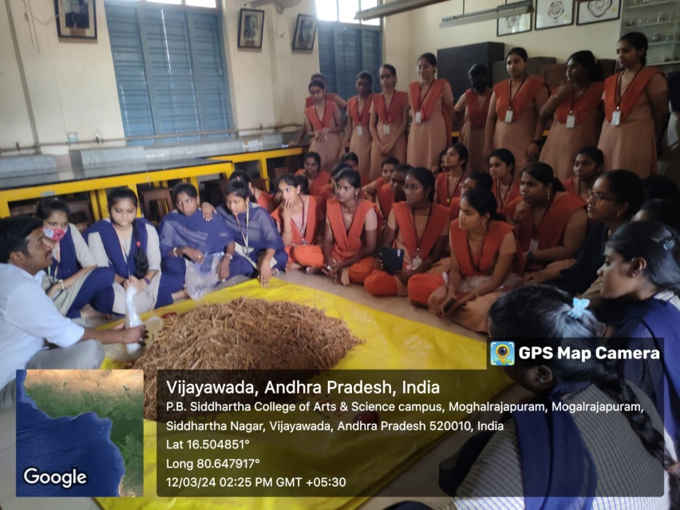
Hands on training given by sri T. Jaya chand
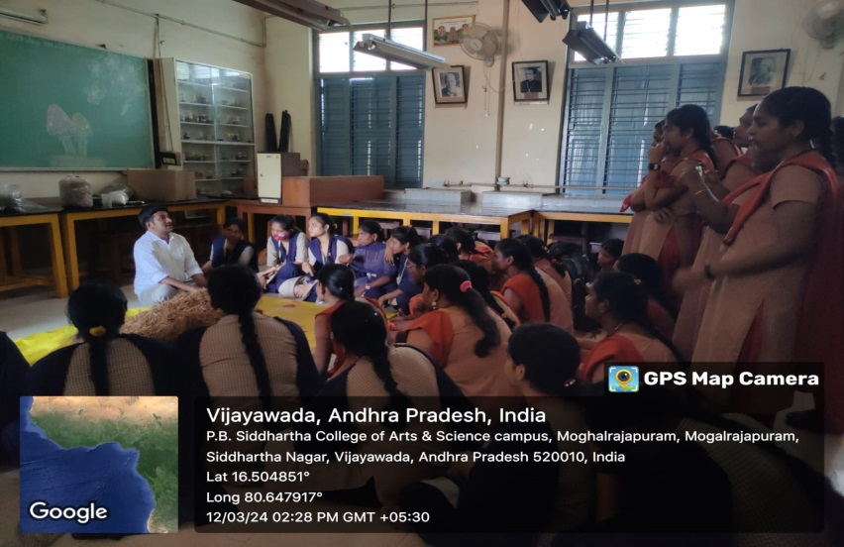
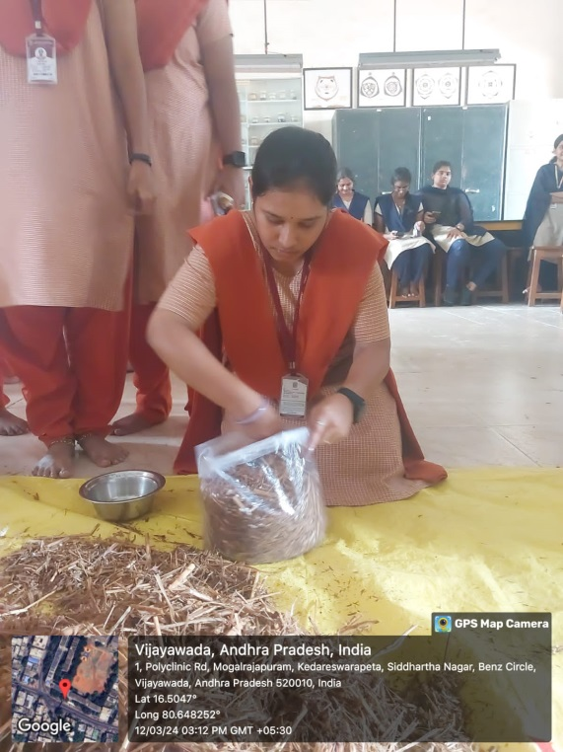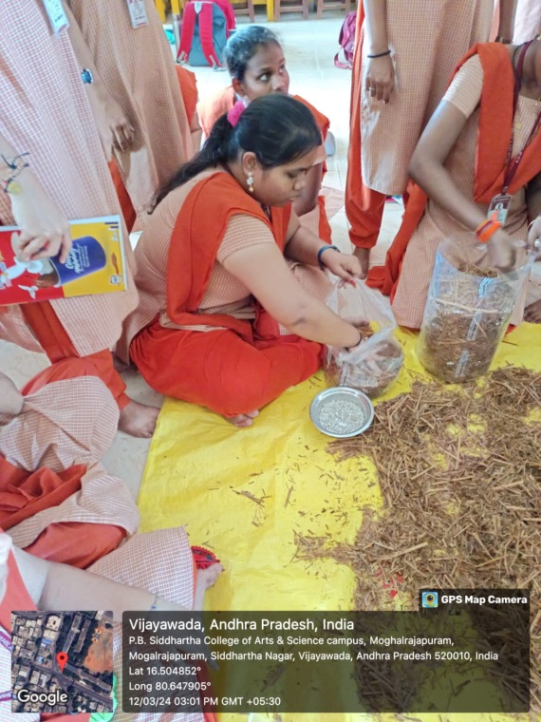
SPAWNING BY SOWMYA II BZC COMPOSTING BY Y.SATYA DEEPIKA IIBZC
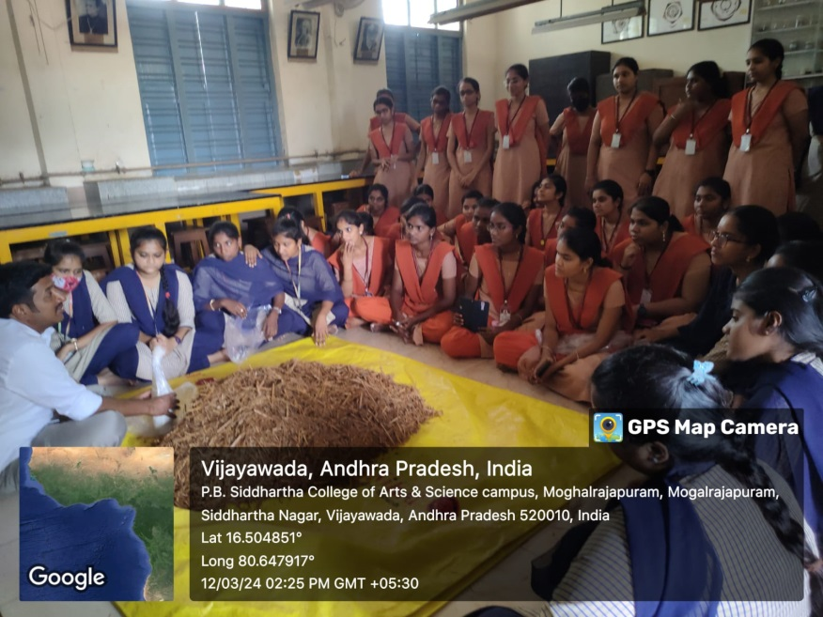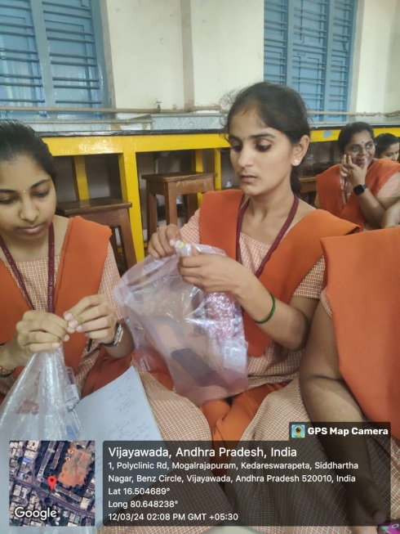
bag preparation byB.NEERAJA G.Deepth II BZC

