

Report on the Guest Lecture
“Modern Approach to Mathematics:Numerical Methods with Uncertainity Analysis”
Organized by Department of Mathematics

Day & Date: Wednesday 21-08-2024
Venue: Webinar Hall
Time: 11:00AM-1.00PM
PARTICIPANTS: Students of II B.Sc Honours Mathematics and
III B.Sc MECS,MSCS(A),MSCA
RESOURCE PERSON:Dr.Sukanta Nayak, Assistant Professor Senior Grade2
Department of Mathematics,
VIT-APUniversity,Amaravati.

INVITATION:

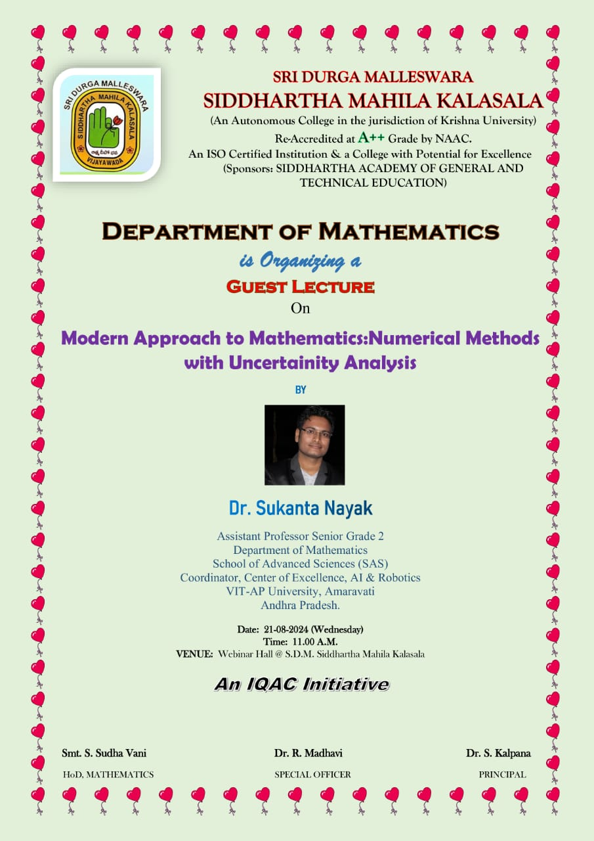
PROGRAMME SCHEDULE FOR GUEST LECTURE
S.NO | PROGRAMME PARTICULARS | TIME
1 | Greetings | 11.00-11.05am
2 | Welcoming the Guest | 11.05-11.10am
3 | Prayer Song | 11.10-11.15am
4 | Bio-Data of Resource Person | 11.15-11.20am
5 | Principal opening marks | 11.20-11.25am
6 | Addressing the Gathering by Special Officer | 11.25-11.30am
7 | Guest Talk | 11.30-12.55pm
8 | Vote of Thanks | 12.55-1.00pm

OBJECTIVE: The primary objective of the guest lecture was to familiarize students and faculty with advanced numerical methods in mathematics, emphasizing the integration of uncertainty analysis.

PROGRAMME HIGHLIGHTS

- The Department of Mathematics organized an insightful guest lecture on the topic “Modern Approach to Mathematics: Numerical Methods with Uncertainty Analysis.” The event took place on 21st August 2024 and featured Dr.Sukanta Nayak, a distinguished expert in the field, as the resource person.

WELCOMING THE GUEST

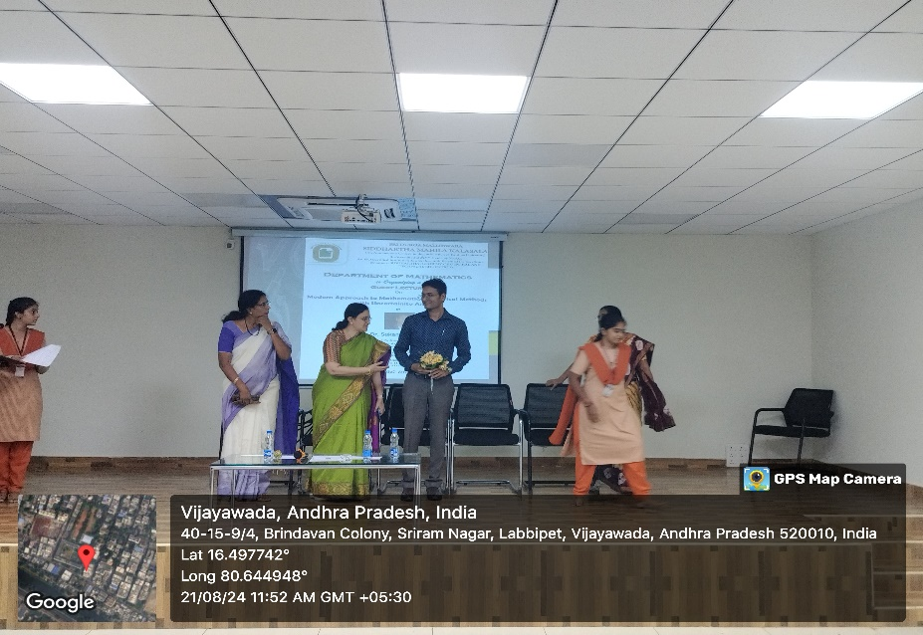

PRAYER SONG BY THE STUDENT

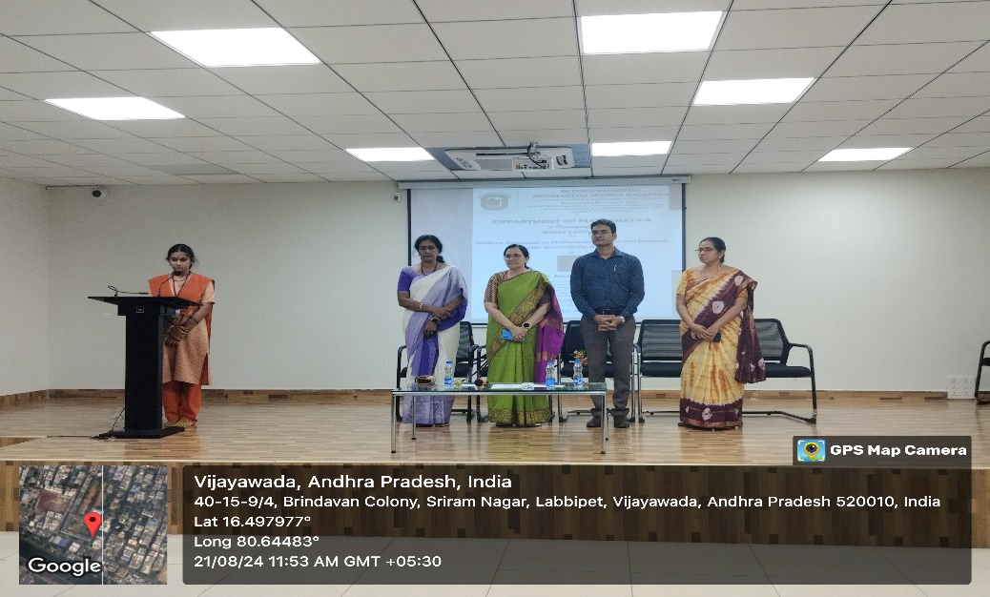

BIO-DATA OF RESOURCE PERSON
- Dr.Sukanta Nayak is currently working as an Assistant Professor(Senior) Mathemaics at VIT-AP University.
- He has done his Postdoc from University of Johannesburg, South Africa.
- Till now he authored 3 books.
- He was awarded a PG Scholarship funded by Government of Odisha, Year 2008.
- His research interest spans both uncertainty analysis and its engineering applications.

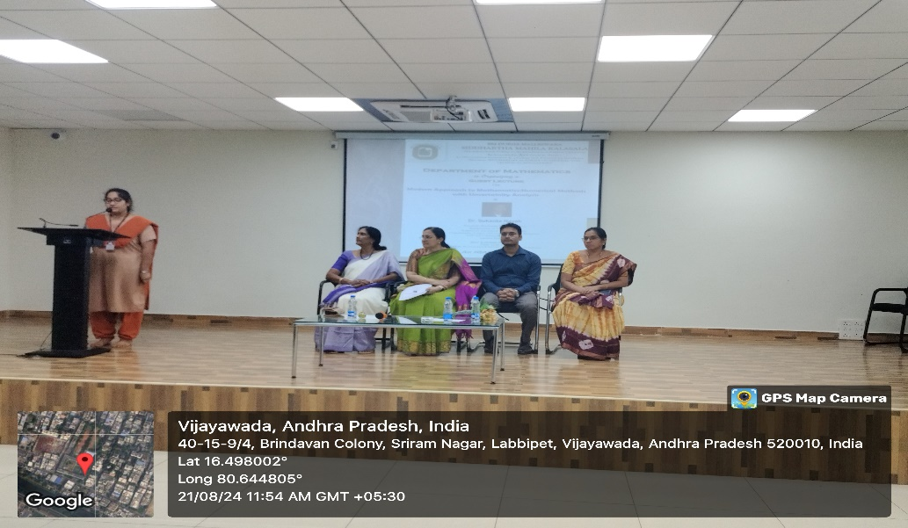

PRINCIPAL OPENING MARKS

- The session began with a warm welcome from Dr.S.Kalpana, Principal, who introduced the speaker and highlighted the importance of integrating modern approaches in mathematical studies.

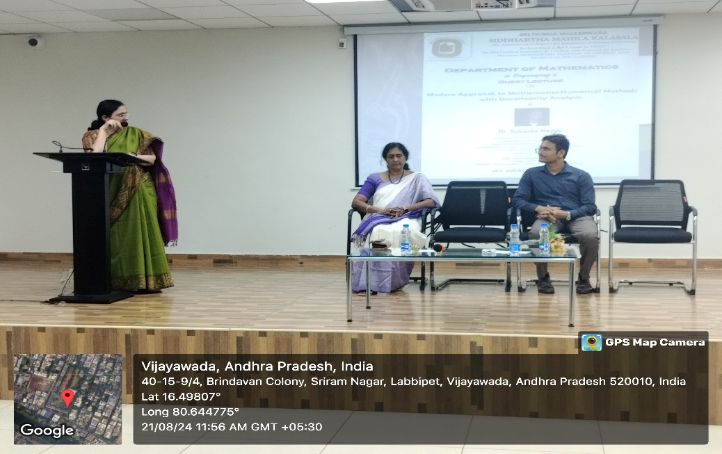

ADDRESSING THE GATHERING BY SPECIAL OFFICER

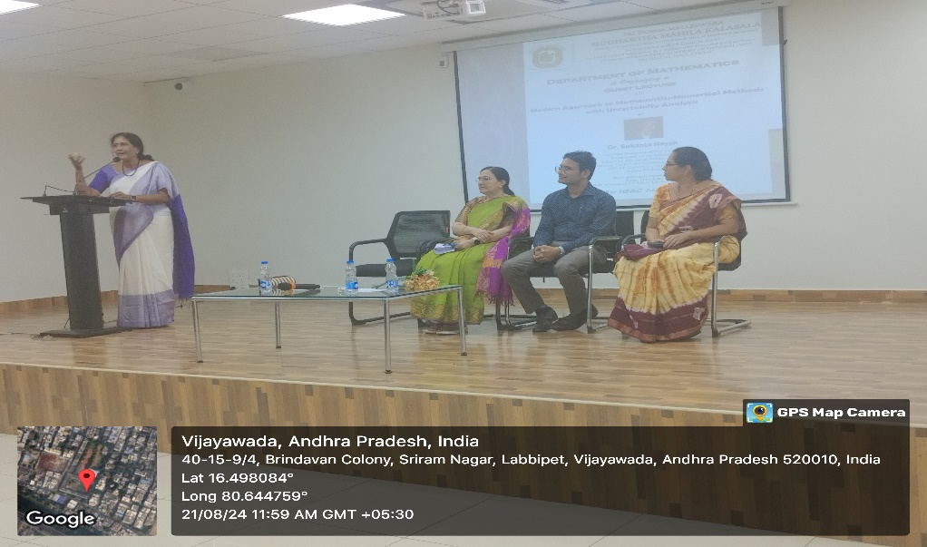

GUEST TALK

- The guest speaker then took the stage to explore the evolving landscape of numerical methods and the role of uncertainty analysis in solving complex mathematical problems.

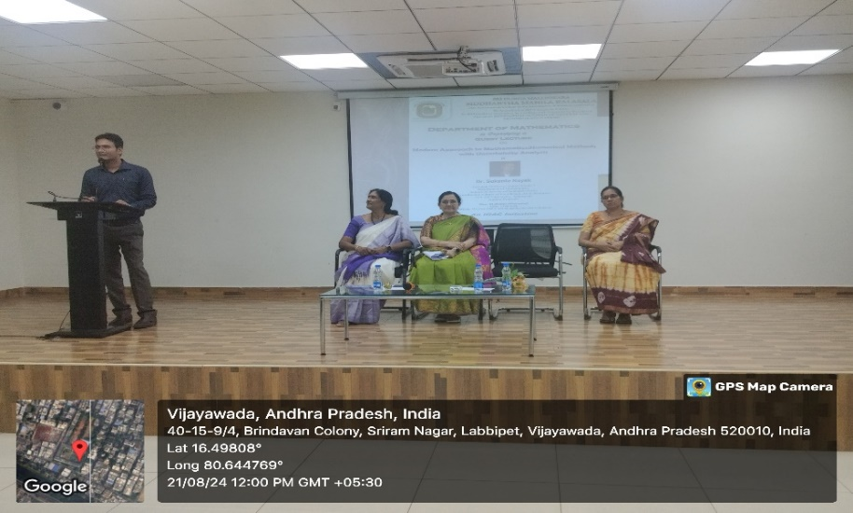
- During the lecture, the speaker provided an in-depth overview of various numerical techniques used in contemporary mathematics. A key focus was on how uncertainty analysis can enhance the accuracy and reliability of these methods. The presentation included real-world examples that demonstrated the significance of considering uncertainties in numerical computations.
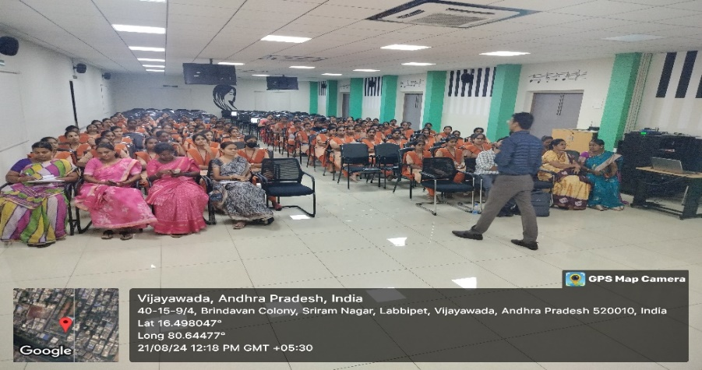

Key points covered
1.Approaches in Mathematics
2.Classical Analysis VS Numerical Analysis
3.Dimensions in Numerical Analysis
4.Numerical Methods
5.Uncertainities
6.Fuzzy logic & Fuzzy Set Theory
7.Optimizing approach
8.Artificial Neural Network Techniques
9.Opportunities: Research & Industrial Jobs

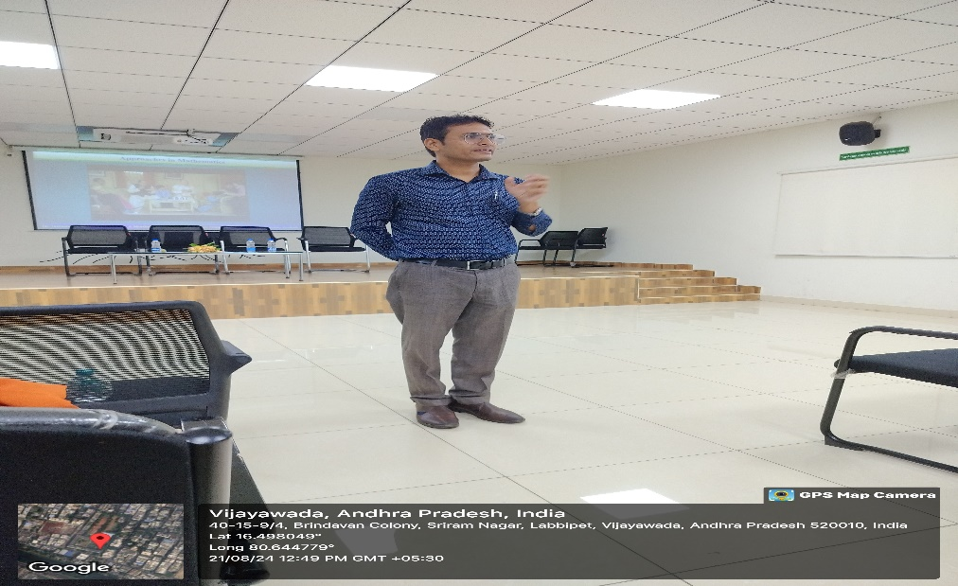

- The interactive session that followed allowed students to engage with the speaker, asking questions and discussing the applications of these methods in various fields. The students and faculty members found the lecture highly informative and beneficial, particularly in understanding the practical implications of the concepts discussed.

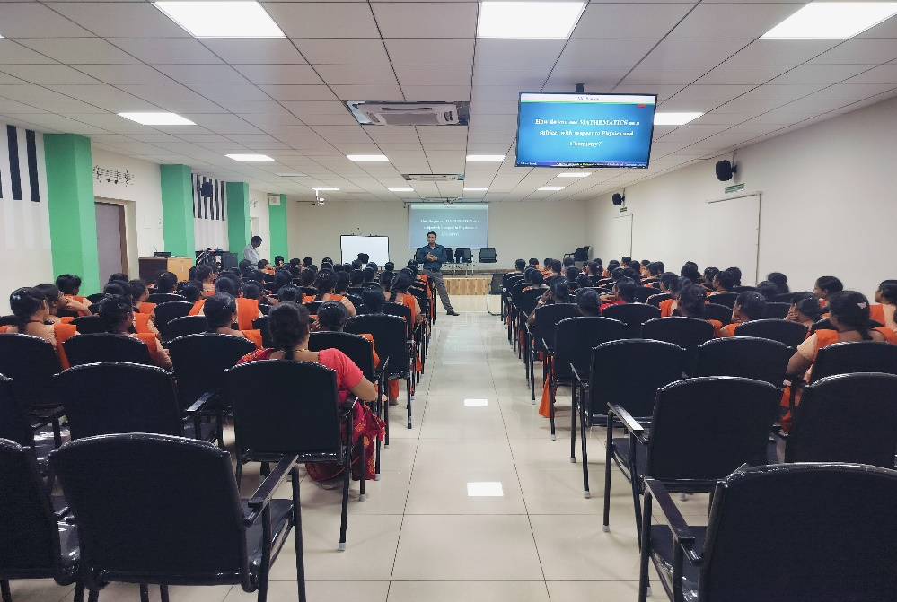

- The event concluded with a vote of thanks by N.Jyothi of II B.Sc Maths, who expressed gratitude to the speaker for sharing their expertise and to all participants for their active involvement.

CONCLUSION: Overall, the guest lecture provided valuable insights into modern mathematical approaches, equipping students and faculty with advanced tools and perspectives to approach mathematical challenges with greater precision

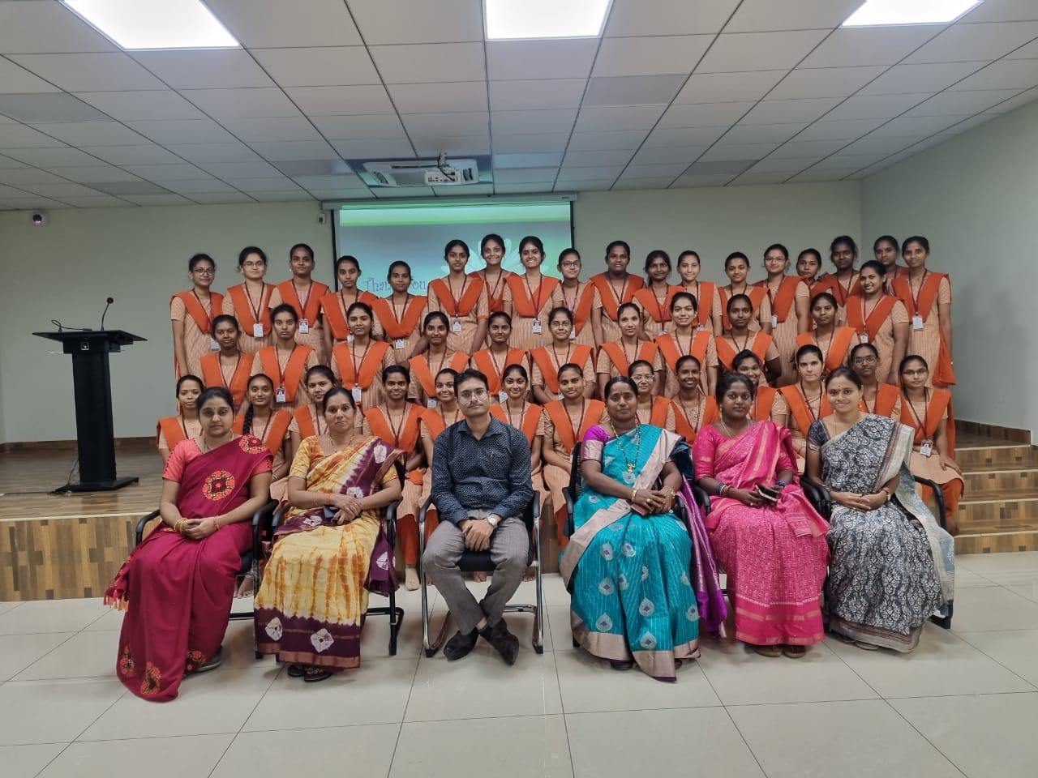

FEEDBACK FROM STUDENTS

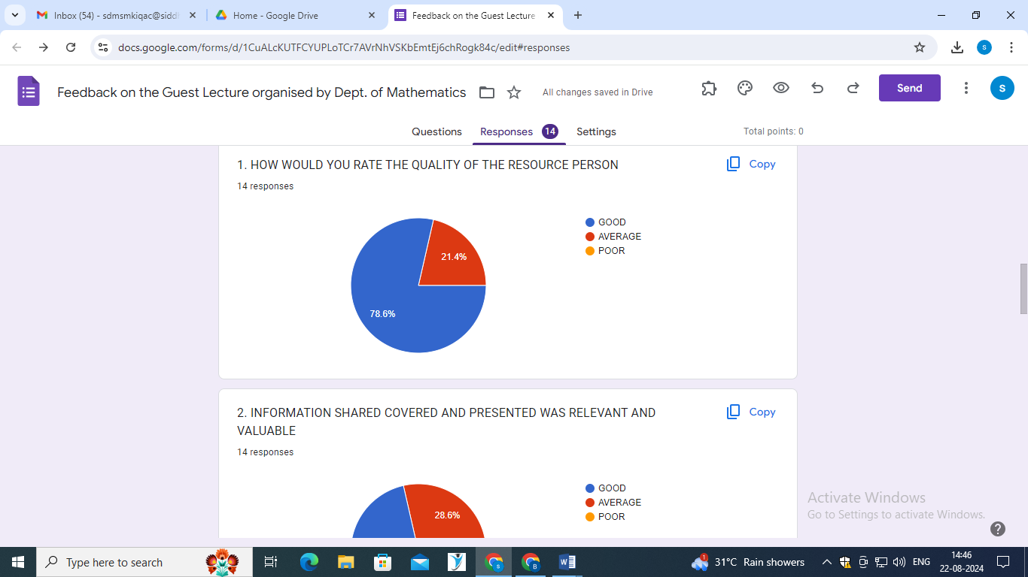

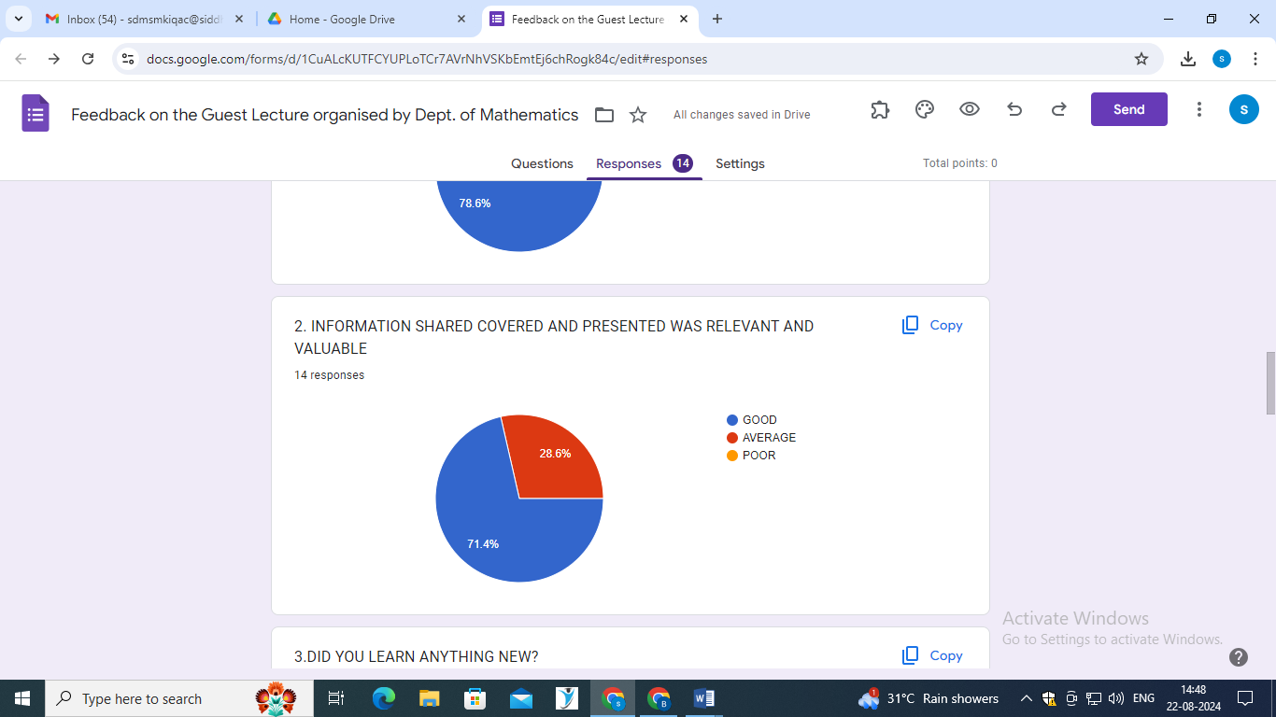
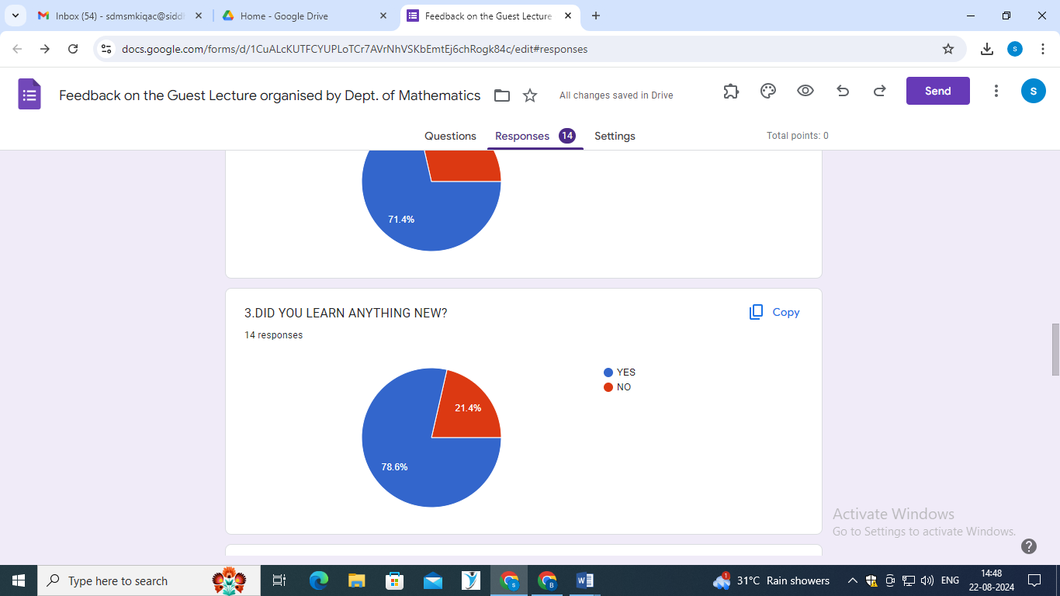

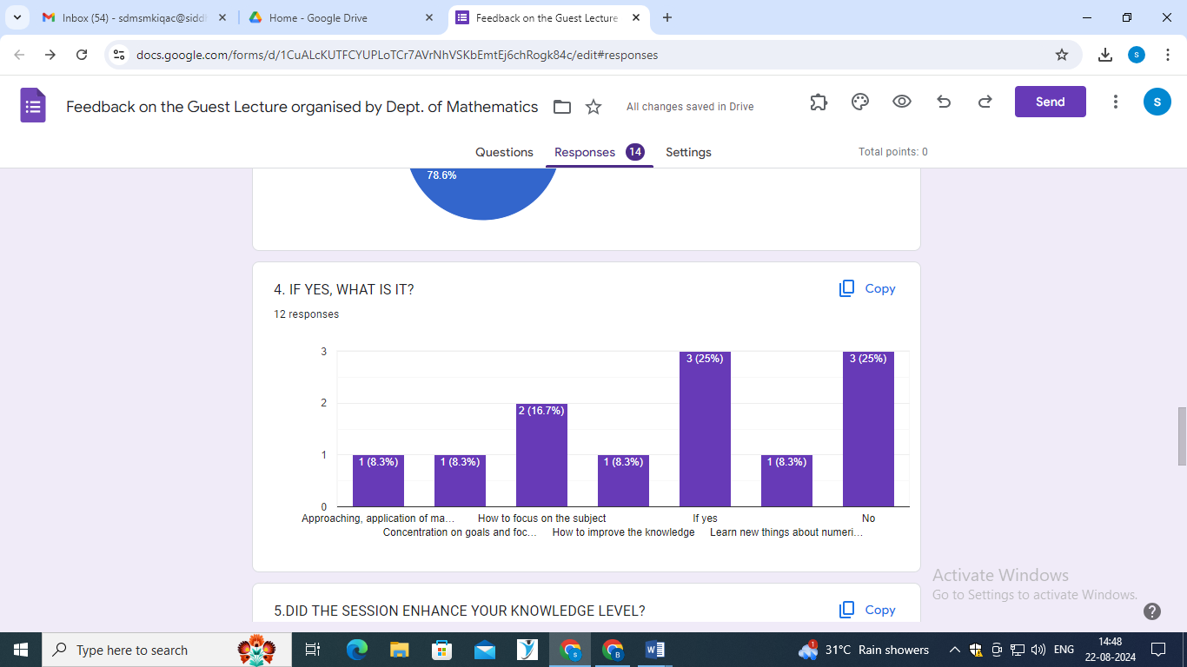

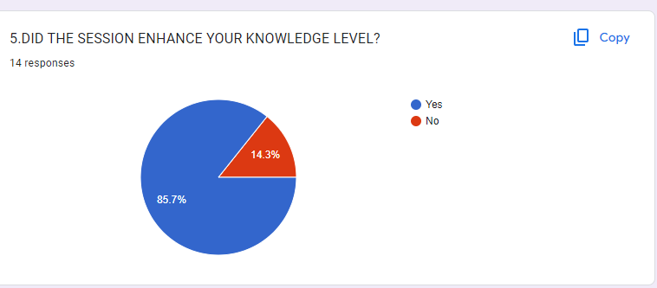

MEDIA COVERAGE OF THE PROGRAMME

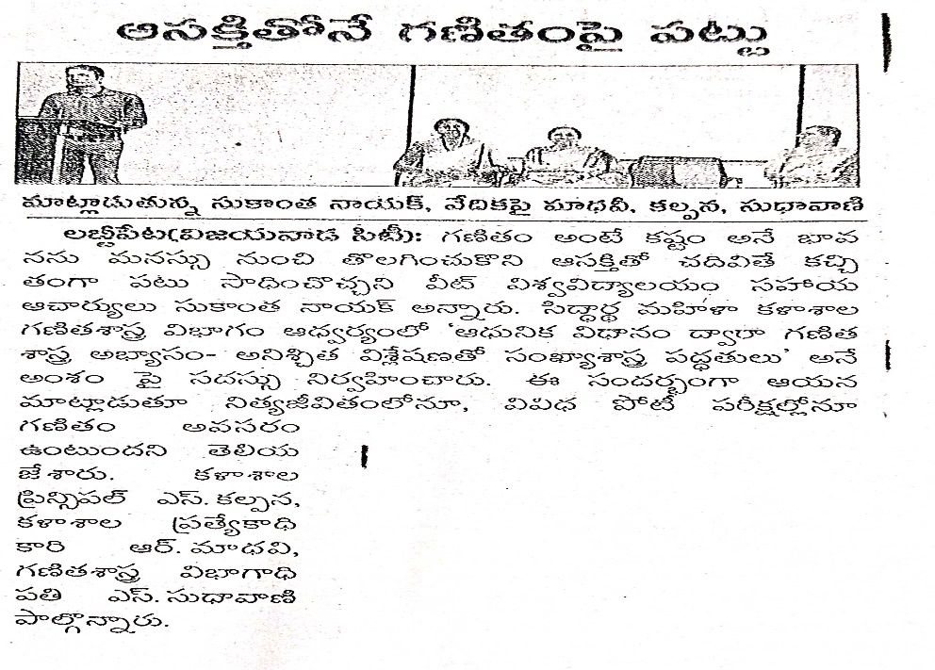

ATTENDANCE SHEET

